

A PROJECT REPORT

ON

ONLINE SHOPPING

DONE BY

Pratidnya Chandrakant Khedekar

(EBTSOC0920316869)

Under the Guidance of,

**Mr. V JAYANTH**

**Technical Trainer**

**NASSCOM PROJECT**

**­**

**ARISE**

**ONCAMPUS**

**SOFTWARE DEVELOPER TRAINEE**

Thane -40602

2020

**­­­­**

**ABSTRACT**

## Online shopping system is a system which is developed to improve the services of customers and vendors. The main features of this project is high accuracy, design flexibility and easy availability. This application allows customers to shop and buy the items online.

## This online shopping system allows users to shop from anywhere and anytime. This system provides users to find more variety of products with fewer expenses. Users can compare multiple items at a time in this application. This application saves lot of time and users can avoid crowd for shopping.

This Online Shopping System application maintains the details of the customer payments, product receipts and all the details of the selected items

**TABLE OF CONTENT**

**S. TITLE PAGE NO**

ABSTRACT 2

**1. INTRODUCTION**

Introduction 5

**2. SCOPE& OBJECTIVES**

SCOPE 7

OBJECTIVES 7

**3. LITRATURE REVIEW**

Existing System 8

Proposed System 9

**4.Software & Hardware**

Software 10

Hardware 10

**5. SYSTEM ANALYSIS**

FUNCTIONAL REQUIREMENTS USER 11

User Case Diagram 13

Admin Diagram 14

Class Diagram 15

Activity Diagram 16

Sequence Diagram 17

OVERVIEW OF ONLINE SHOPPING 17

e-Shopping 18

**6. SYSTEM DESIGN**

System Design 19

INPUT AND OUTPUT DESIGN 19

DATABASE 20

**7. CONCLUSION** 21

**8. REFERENCES** 22

**APPENDIX-I** 23

SNAPSHOTS23

SOURCE CODE 29

**CHAPTER – 1**

**INTRODUCTION**

An Online Shopping system that a customer to submit orders for item and/or services from a store that service both walk-in customers and online customers and online customer the online electronic shopping system presents on online display of an order cut off time and associated delivery window for items selected by the customer. The system accepts the customer submission of a purchase order for the item response to a time of submission being before the order cutoff line time.

The online shopping system does not settle with a credit supplier system of the customer until the item selected by the customer is picked from inventory but before it is delivered. Therefore the customer can go online and make changes to the order. In addition, available services windows are presented to the customer as a function of customer selected order and service types and further the order picking assigned in accordance with pickers performance.

The development of this new system contains the following activities, which try to develop on-line application by keeping the entire process in the view of database integration approach.

* Secure registration and profile management facilities for Customers.
* Browsing through the e-Mall to see the items that are there in each category of products like Apparel, Kitchen accessories, Bath accessories, Food items etc.
* Creating a Shopping cart so that customer can Shoppe ‘n’ no. of items and checkout finally with the entire shopping cart
* Customers should be able to mail the Shop about the items they would like to see in the Shop
* Secured mechanism for checking out from the Shop( Credit card verification mechanism )
* Updates to customers about the Recent Items in the Shop.
* Uploading ‘Most Purchased’ Items in each category of products in the Shop like Apparel, Kitchen accessories, Bath accessories, Food items etc.

Number of Modules

The system after careful analysis has been identified to be presented with the following modules:

* Customer.
* Admin Module.
* Security and Authentication

**2. SCOPE & OBJECTIVES**

**SCOPE**

This system can be implemented to any shop in the locality or to multinational branded shops having retail outlet chains. The system recommends a facility to accept the orders 24*7 and a home delivery system which can make customers happy. If shops are providing an online portal where their customers can enjoy easy shopping from anywhere, the shops won’t be losing any more customers to the trending online shops such as flip cart or eBay.

**OBJECTIVE**

The objective of the project is to make an application in android platform to purchase items in an existing shop. In order to build such an application complete web support need to be provided. A complete and efficient web application which can provide the online shopping experience is the basic objective of the project.

**CHAPTER – 3**

**LITERATURE REVIEW**

**Existing System:**

There are a number of ways to shop online. First, you will need to have your credit card

handy as most sites will want to have that information. Always make you sure the web address starts with https:// before putting your credit card info in (at checkout). You can go directly to the site which sells what want.

For example, you can shop at Walmart and JC Penney. Another way to shop online is to use auction sites like E bay. Like most people these days, we had grown accustomed to using search engines to find just about anything.

But shopping on my favorite search engine is far from ideal. I have been shopping online for quite some time and find it very convenient.

Besides I use a free toolbar -Billeo which makes it much easier. It does stuff like saving receipts, managing, password etc.

**Proposed System:**

The development of this new system contains the following activities, which try to develop on-line application by keeping the entire process in the view of database integration approach.

* Secure registration and profile management facilities for Customers.
* Browsing through the e-Mall to see the items that are there in each category of products like Apparel, Kitchen accessories, Bath accessories, Food items etc.
* Creating a Shopping cart so that customer can Shoppe ‘n’ no. of items and checkout finally with the entire shopping cart
* Customers should be able to mail the Shop about the items they would like to see in the Shop
* Secured mechanism for checking out from the Shop( Credit card verification mechanism )
* Updates to customers about the Recent Items in the Shop.
* Uploading ‘Most Purchased’ Items in each category of products in the Shop like Apparel, Kitchen accessories, Bath accessories, Food items etc.

Number of Modules

The system after careful analysis has been identified to be presented with the following modules:

* Customer.
* Admin Module.
* Security and Authentication

**CHAPTER – 4**

**Software & Hardware**

**Software Requirements:**

Operating System : Windows 10

User Interface : HTML, CSS

Client-side Scripting : JavaScript

Web Applications : JDBC, Servlets, JSP

IDE : Eclipse

Database : My Sql

Server Deployment : Tomcat v8.5

**Hardware Requirements:**

Processor : CORE i3

## Hard Disk : 1TB

RAM : 8GB

**CHAPTER – 5**

**SYSTEM ANALYSIS**

**FUNCTIONAL REQUIREMENTS USER**

**USER LOGIN**

This feature used by the user to login into system. A user must login with his user name and password to the system after registration. If they are invalid, the user not allowed to enter the system.

Functional requirement :

Username and password will be provided after user registration is confirmed.

Password should be hidden from others while typing it in the field

**REGISTER NEW USER**

A new user will have to register in the system by providing essential details in order to view the products in the system. The admin must accept a new user by unblocking him.

Functional requirement :

System must be able to verify and validate information.

The system must encrypt the password of the customer to provide security.

**PURCHASING AN ITEM**

The user can add the desired product into his cart by clicking add to cart option on the product. He can view his cart by clicking on the cart button.

All products added by cart can be viewed in the cart. User can remove an item from the cart by clicking remove. After confirming the items in the cart the user can submit the cart by providing a delivery address. On successful submitting the cart will become empty.

Functional requirement:

System must ensure that, only a registered customer can purchase items.

**ADMIN**

**MANAGE USER**

The administrator can add user, delete user, view user and block user.

**MANAGE MODERATOR**

The administrator can add moderator, delete moderator, block moderator and search for a moderator.

**MANAGE PRODUCTS**

The administrator can add product, delete product and view product.

**MANAGE ORDERS**

The administrator can view orders and delete orders. Functional requirements -The system must identify the login of the admin

Admin account should be secured so that only owner of the shop can access that account

**DIAGRAM**

**USE CASE DIAGRAM:**

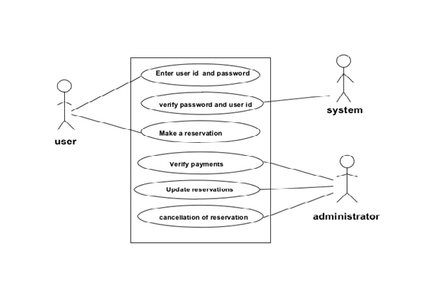

Fig.User case dig

ADMIN DIAGRAM:

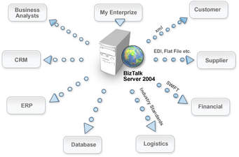

Fig.Admin dig

SEQUESTIOAL DIAGRAM:

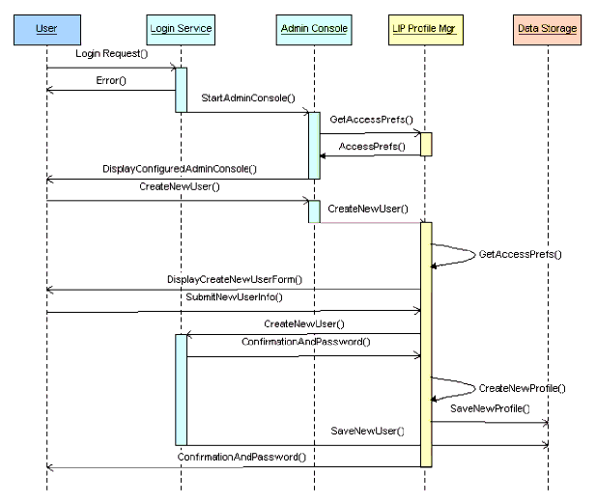

Fig. SEQUESTIOAL dig

CONTEXT LEVEL DATA FLOW DIAGRAM

SELLER

BUYER

SELLER

BUYER

Fig.Data flow dig

**OVERVIEW OF ONLINE SHOPPING**

The central concept of the application is to allow the customer to shop virtually using the Internet and allow customers to buy the items and articles of their desire from the store. The information pertaining to the products are stores on an RDBMS at the server side (store). The Server process the customers and the items are shipped to the address submitted by them. The application was designed into two modules first Os for the customers who wish to buy the articles.Second is for the storekeepers who maintains and updates the information pertaining to the articles and those of the customers? The end user of this product is a departmental store where the application is hosted on the web and the administrator maintains the database. The application which is deployed at the customer database, the details of the items are brought forward from the database for the customer view based on the selection through the menu and the database of all the products are updated at the end of each transaction. Data entry into the application can be done through various screens designed for various levels of users. Once the authorized personnel feed the relevant data into the system, several reports could be generated as per the security.

**e-Shopping**

[Online shopping](http://en.wikipedia.org/wiki/Online_shopping)is a form of electronic commerce where the buyer is directly online tothe seller's computer usually via the internet. There is no intermediary service. The sale and purchase transaction is completed electronically and interactively in real-time such as Amazon.com for new books. If an intermediary is present, then the sale

and purchase transaction is called electronic commerce such as [eBay.com](http://en.wikipedia.org/wiki/EBay.com).

**CHAPTER – 6**

**SYSTEM DESIGN**

**System Design:**

System design is the solution for the creation of a new system. This phase focuses on the detailed implementation of the feasible system. It emphasis on translating design. Specifications to performance specification. System design has two phases of development

* Logical design
* Physical design

During logical design phase the analyst describes inputs (sources), output s(destinations), databases (data sores) and procedures (data flows) all in a format that meets the user requirements. The analyst also specifies the needs of the user at a level that virtually determines the information flow in and out of the system and the data resources. Here the logical design is done through data flow diagrams and database design. The physical design is followed by physical design or coding. Physical design produces the working system by defining the design specifications, which specify exactly what the candidate system must do. The programmers write the necessary programs that accept input from the user, perform necessary processing on accepted data and produce the required report on a hard copy or display it on the screen.

**INPUT AND OUTPUT DESIGN**

**INPUT DESIGN:**

Input design is the link that ties the information system into the world of its users. The input design involves determining the inputs, validating the data, minimizing the data entry and provides a multi-user facility. Inaccurate inputs are the most common cause of errors in data processing. Errors entered by the data entry operators can be controlled by input design. The user-originated inputs are converted to a computer based format in the input design. Input data are collected and organized into groups of similar data. Once identified, the appropriate input media are selected for processing. All the input data are validated and if any data violates any conditions, the user is warned by a message. If the data satisfies all the conditions, it is transferred to the appropriate tables in the database. In this project the student details are to be entered at the time of registration. A page is designed for this purpose which is user friendly and easy to use. The design is done such that users get appropriate messages when exceptions occur.

**OUTPUT DESIGN:**

Computer output is the most important and direct source of information to the user. Output design is a very important phase since the output needs to be in an efficient manner. Efficient and intelligible output design improves the system relationship with the user and helps in decision making. Allowing the user to view the sample screen is important because the user is the ultimate judge of the quality of output. The output module of this system is the selected notifications.

**DATABASE**

**DATABASE DESIGN:**

Databases are the storehouses of data used in the software systems. The data is stored in tables inside the database. Several tables are created for the manipulation of the data for the system. Two essential settings for a database are - the field that is unique for all the record occurrences. the field used to set relation between tables. Normalization is a technique to avoid redundancy in the tables.

**SYSTEM TOOLS**

The various system tools that have been used in developing both the front end and the back end of the project are being discussed in this chapter..

**CONCLUSIONS**

The central concept of the application is to allow the customer to shop virtually using the Internet and allow customers to buy the items and articles of their desire from the store.

The information pertaining to the products are stores on an RDBMS at the server side (store).The Server process the customers and the items are shipped to the address submitted by them.

The application was designed into two modules first Os for the customers who wish to buy the articles. Second is for the storekeepers who maintains and updates the information pertaining to the articles and those of the customers.

The end user of this product is a departmental store where the application is hosted on the web and the administrator maintains the database. The application which is deployed at the customer database, the details of the items are brought forward from the database for the customer view based on the selection through the menu and the database of all the products are updated at the end of each transaction.

**REFERENCES**

[1] JavaScript Enlightenment,Cody Lindley-First Edition, based on JavaScript 1.5, ECMA-262, Edition

[2] Mc GrawHill’s , Java : The complete reference 7thEdition, Herbert Schildit

[3] Complete CSS Guide ,Maxine Sherrin and John Allsopp-O'Reilly Media; September 2012

[4]<http://www.w3schools.com/html/defualt.asp>,

<http://www.w3schools.com/css/default.asp>,

http://www.w3schools.com/js/default.asp

**APPENDIX-I**

**SNAPSHO**



Img. Admin Login

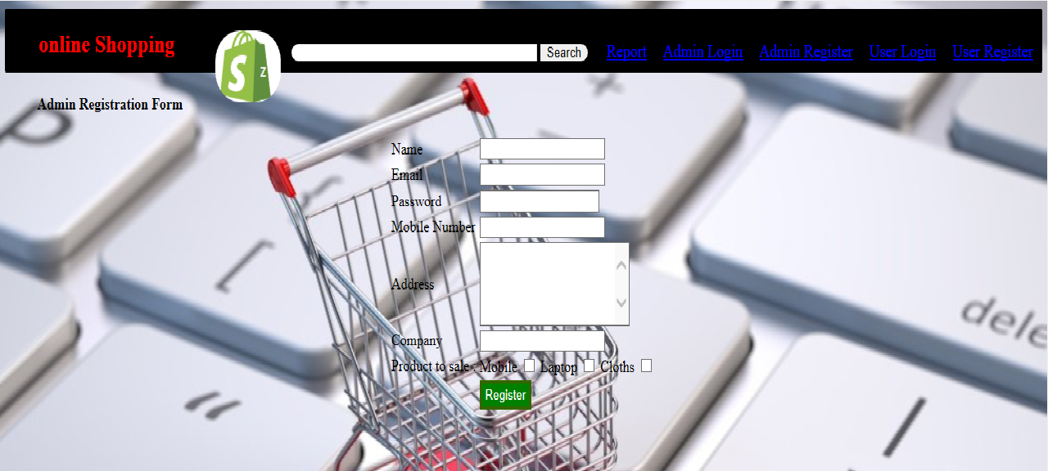

Img. Admin Registration Form

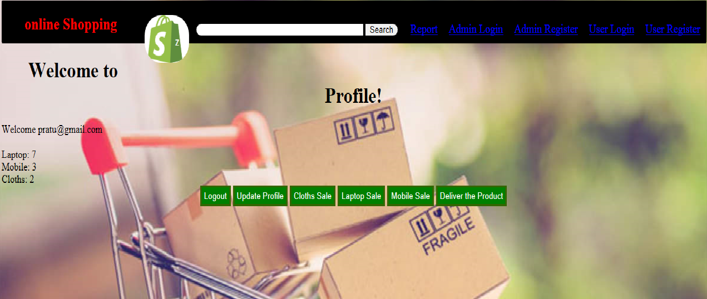

Img. Admin Profile



Img. Admin Update Profile

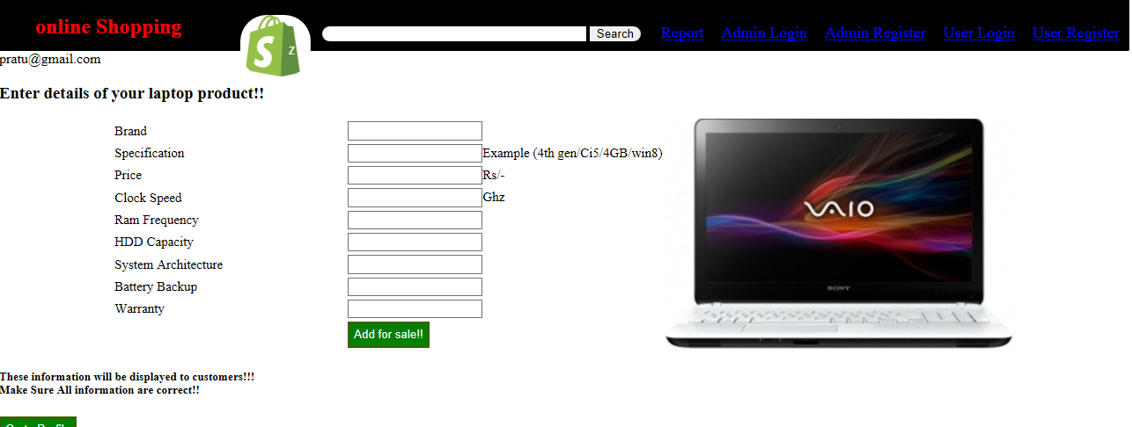

Img .Add Laptop Product

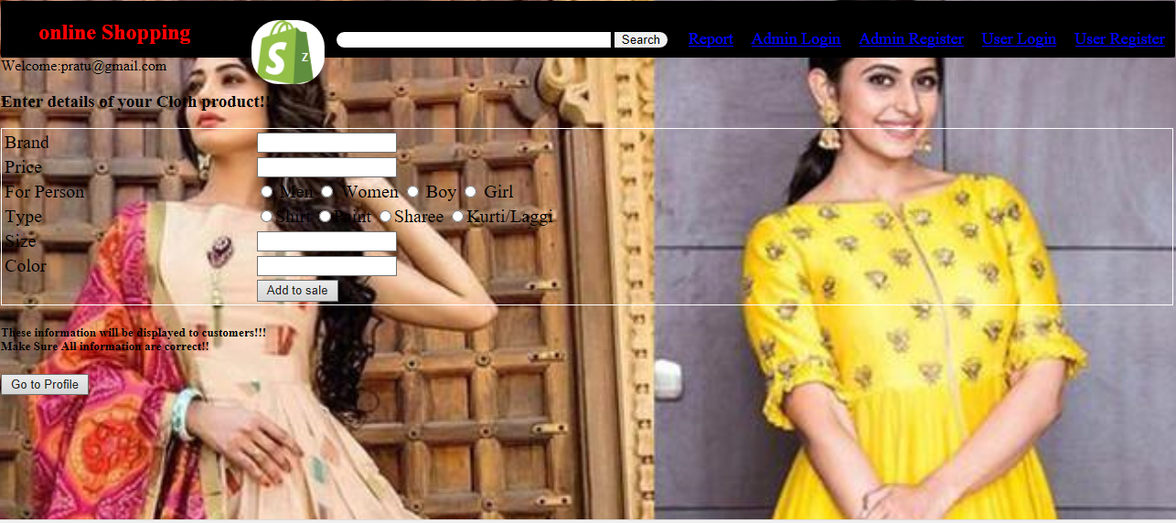

Img . Add Cloth Product

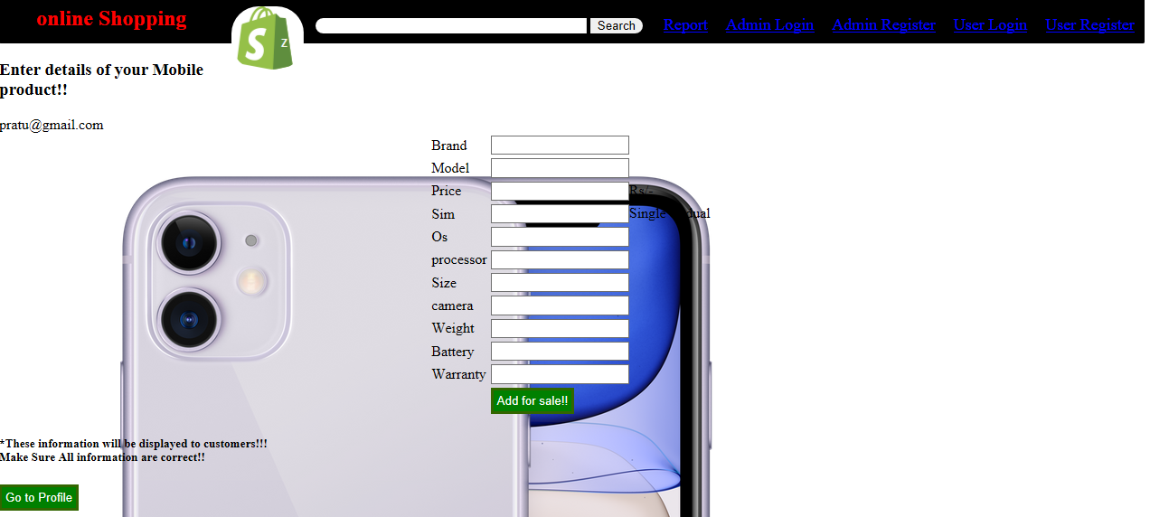

Img . Add Mobile Product



Img. Shopping Product

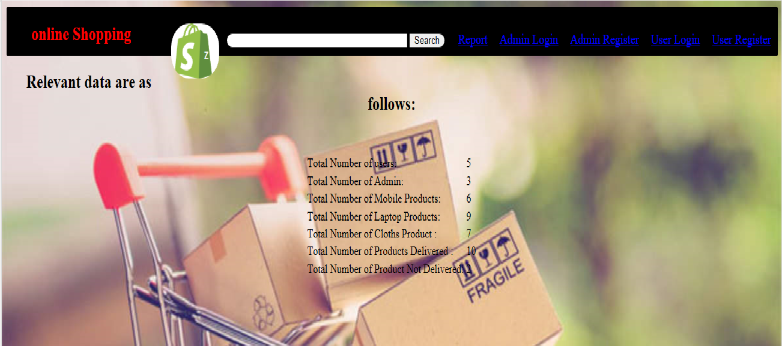

Img. Report

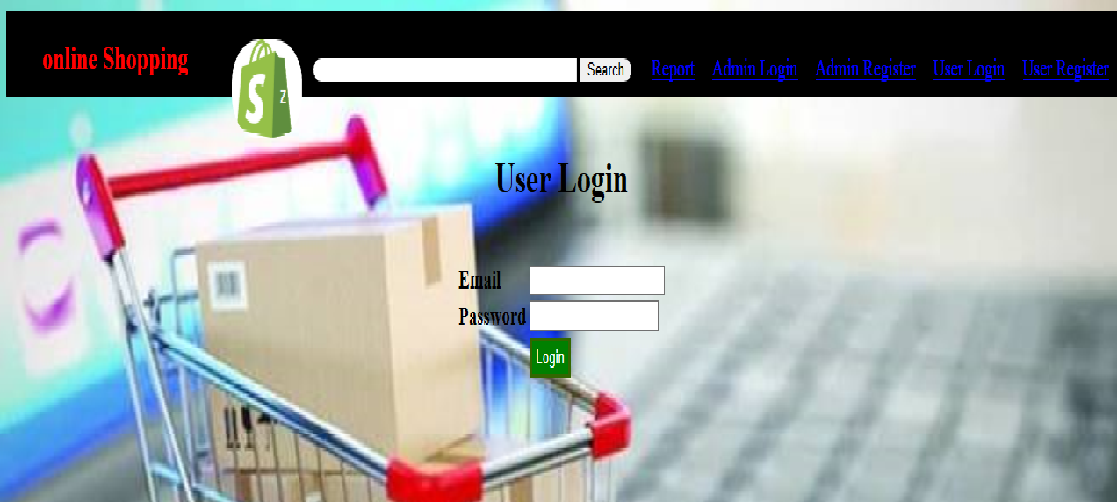

Img. User Login

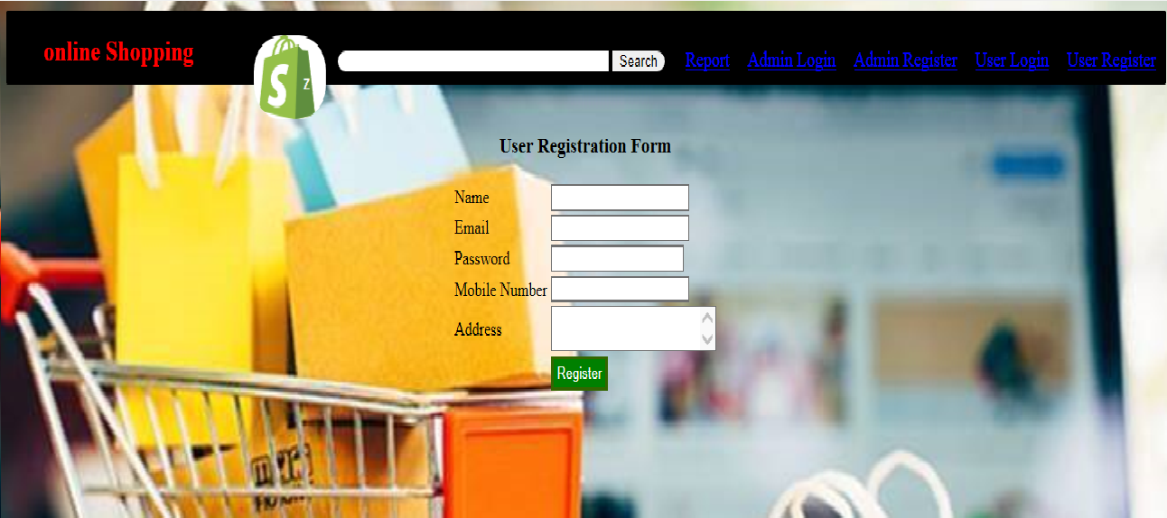

Img.User Registration page

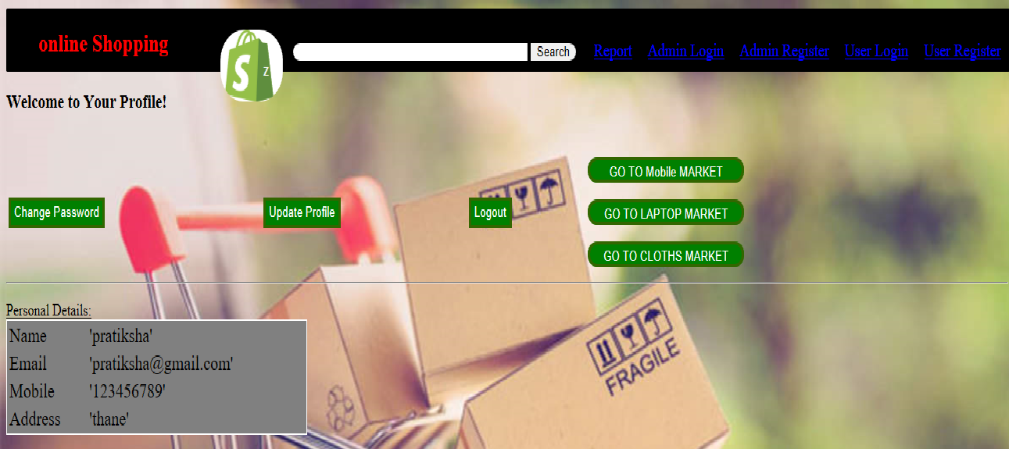

Img.User Profile

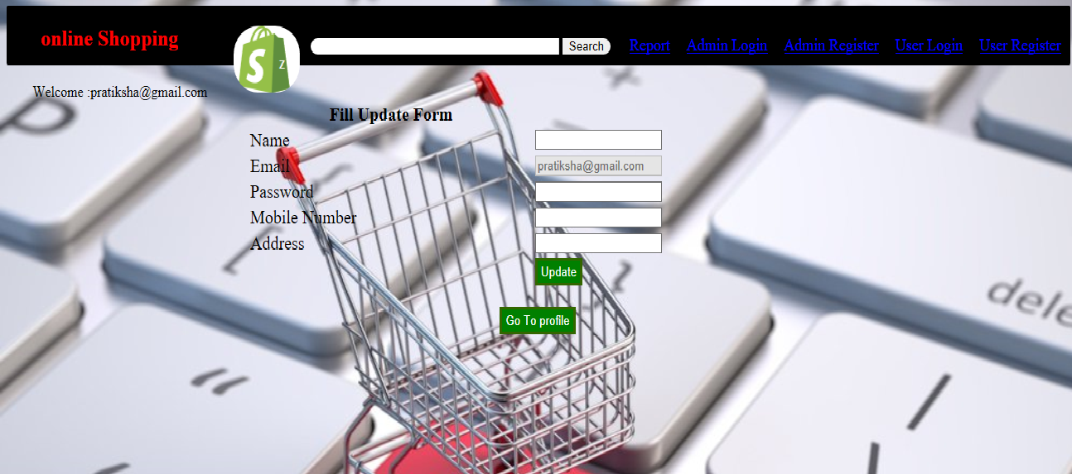

Img.User Update Form

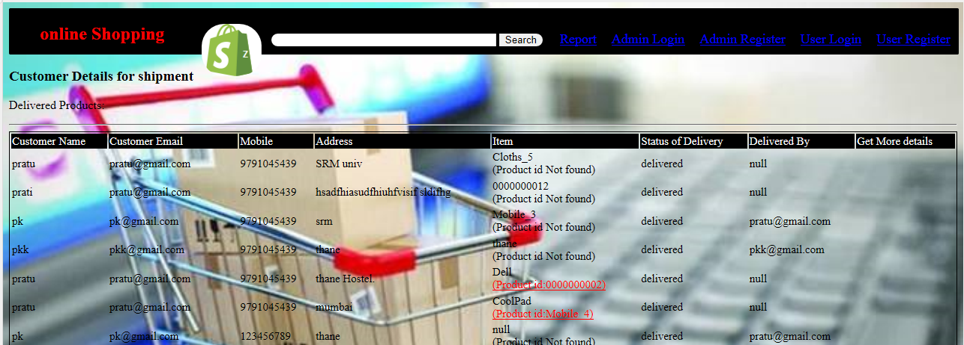

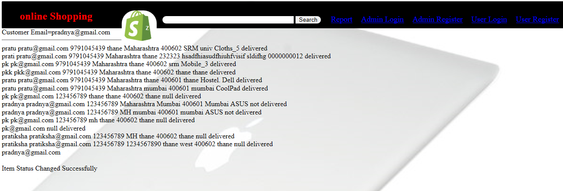

**SOURCE CODE**

<%@page import=*"java.sql.* "* %>

<%@include file=*"header.jsp"* %>

<%@page contentType=*"text/html"* pageEncoding=*"UTF-8"*%>

<!DOCTYPE html>

<html>

<head>

<meta http-equiv=*"Content-Type"* content=*"text/html; charset=UTF-8"*>

<title>Change Password</title>

<style>

*.tbl* {

border: *1px solid black*;

width: *100%*;

font-size: *20px*;

color: *black*;

background-position: *right*;

}

**body** {

background-image: *url('Images/pic6.jpg')*;

background-repeat: *no-repeat*;

background-attachment: *fixed*;

background-size: *cover*;

}

</style>

<script>

**function** validateForm() {

**var** x = document.forms["myForm"]["t1"].value;

**if** (x == **null** || x == "") {

alert("Required Field Must Enter New password ");

**return** **false**;

}

}

</script>

</head>

<body>

<center><h1 class=*"heading"*>Change Password</h1></center>

<center>

<form method=*"post"* action=*"user_changePassword.jsp"* onsubmit="return validateForm();" name=*"myForm"*>

<class="tbl" id=*"form1"*>

<tr> <td>

Enter New Password</td><td><input type=*"password"* name=*"t1"* class=*"btn"*></tr>

<tr> <td> </td><td><input type=*"Submit"* value=*"Change Password"* class=*"btn"*style="font-size:*10pt*;color:*white*;background-color:*green*;border:*3px solid #336600*;padding:*4px*"></td>

</table>

</form>

</center>

<%@include file=*"connect.jsp"* %>

<%

**try**

{

String oldpswd,newpswd;

newpswd =request.getParameter("t1");

String name=(String)session.getAttribute("id");

**if**(newpswd!=**null**)

{

PreparedStatement pst=con.prepareStatement("update usertbl set password='"+newpswd+"' where email='"+name+"'");

**int** i=pst.executeUpdate();

**if**(i>0)

{

out.println("Password has been updated");

response.sendRedirect("user_profile.jsp");

}

}

}

**catch**(Exception e)

{

out.println(e);

}

%>

</body>

</html>

<%@page import=*"java.sql.PreparedStatement"*%>

<%@page import=*"java.sql.Connection"*%>

<%@page import=*"java.sql.*"*%>

<%@include file=*"header.jsp"* %>

<%@page contentType=*"text/html"* pageEncoding=*"UTF-8"*%>

<!DOCTYPE html>

<html>

<head>

<meta http-equiv=*"Content-Type"* content=*"text/html; charset=UTF-8"*>

<title>Order for Shipment</title>

<style>

**body** {

background-image: *url('Images/pic2.jpg')*;

background-repeat: *no-repeat*;

background-attachment: *fixed*;

background-size: *cover*;

}

*.tbl*

{

border:*1px solid black*;

width:*100%*;

font-size:*15px*;

color:*black*;

background-position: *right*;

}

*#form1*

{

background-image: *url("Images/A21.jpg")*;

background-repeat: *no-repeat*;

background-color: *white*;

}

</style>

<script>

**function** validateForm() {

**var** x = document.forms["myForm"]["t1"].value;

**if** (x==**null** || x=="") {

alert("Required Field Must Enter person name ");

**return** **false**;

}

}

</script>

</head>

<body>

<h3>Customer Details for shipment</h3>

<div>

<%@include file=*"connect.jsp"* %>

<%

**try**

{

// CODE FOR DELIVERED PRODUCTS:

PreparedStatement pst=con.prepareStatement("select *from purchase where deliver='delivered'");

ResultSet rs=pst.executeQuery();

out.println("<p>Delivered Products:</p><hr><center> <table class=\"tbl\" > "

+ "<tr style='background-color:black;color:white;'> <td>Customer Name</td><td> Customer Email </td>"

+ "<td> Mobile"

//+ "</td><td> State</td><td> City </td><td> Pin</td>"

+ "<td> Address</td> <td>Item</td>"

+ "<td>Status of Delivery</td><td>Delivered By</td><td>Get More details</td> </tr>");

**while**(rs.next())

{

out.println("<tr>");

**for**(**int** i=1;i<=10;i++)

{

**if**(i==4 || i==5 || i==6)

{

**continue**;

}

**else**

{

out.println("<td>"+rs.getString(i)+"");

}

**if**(i==8)

{

Statement st=con.createStatement();

String query[]= **new** String[3];

query[0]="select id from laptop where brand='"+rs.getString(i)+"'";

query[1]="select id from mobile where brand='"+rs.getString(i)+"'";

query[2]="select id from cloths where brand='"+rs.getString(i)+"'";

**boolean** flag=**true**;

**for**(**int** i1=0;i1<3;i1++)

{

ResultSet rsid= st.executeQuery(query[i1]);

**if**(rsid.next())

{

flag=**false**;

out.println("<br><u style='color:red;'>(Product id:"+rsid.getString("id")+")</u>");

}

}

**if**(flag)

{

out.println("<br>(Product id Not found)");

}

}

out.println("</td>");

}

}

out.println("</table> </center>");

///////////////////////////////////////////////////////////////////////////////////////

// CODE FOR NOT DELIVERED PRODUCTS:

PreparedStatement pst_notdelivered=con.prepareStatement("select *from purchase where deliver='not delivered'");

ResultSet rs_notdelivered=pst_notdelivered.executeQuery();

out.println("<p>Not Delivered Products:</p><hr><center> <table class=\"tbl\" > "

+ "<tr style='background-color:black;color:white;'> <td>Customer Name</td><td>Customer Email </td>"

+ "<td> Mobile</td><td> State</td><td> City </td><td> Pin</td><td> Address</td> <td>Item</td>"

+ "<td>Status of Delivery</td> <td>Delivered By</td></tr>");

**while**(rs_notdelivered.next())

{

out.println("<tr>");

**for**(**int** i=1;i<=10;i++)

{

out.println("<td>"+rs_notdelivered.getString(i)+"");

**if**(i==8)

{

Statement st=con.createStatement();

ResultSet rsid= st.executeQuery("select id from laptop where brand='"+rs_notdelivered.getString(i)+"'");

**if**(rsid.next())

{

out.println("<br>(Product id="+rsid.getString(1)+")");

}

**else**

{

out.println("<br>(Not found)");

}

}

out.println("</td>");

}

}

out.println("</table> </center>");

}

**catch**(Exception e)

{

out.println(e);

}

%>

</div>

<br><hr>

<table style="border:*1px solid black*; ">

<th style="background-color:*black*;color:*white*;">Update delivery status:</th>

<form method=*"post"* action=*"deliver.jsp"* onsubmit="return validateForm();" name=*"myForm"*>

<tr><td> Enter customer Email to update Delivery Status :</td><td><input type=*"text"* name=*"t1"*></td></tr>

<!-- <tr><td> Enter customer Product id to update Product details :</td><td><input type="text" name="t2"></td></tr> -->

<tr><td></td><td><input type=*"submit"* value=*"Update!!"*> </td></tr>

</form>

</table>

</body>

</html>

<%@page import=*"java.sql.PreparedStatement"*%>

<%@page import=*"java.sql.Connection"*%>

<%@page import=*"java.sql.*"*%>

<%@page contentType=*"text/html"* pageEncoding=*"UTF-8"*%>

<%@include file=*"header.jsp"* %>

<!DOCTYPE html>

<html>

<head>

<meta http-equiv=*"Content-Type"* content=*"text/html; charset=UTF-8"*>

<title>Welcome</title>

<style>

**body** {

background-image: *url('Images/pic4.jpg')*;

background-repeat: *no-repeat*;

background-attachment: *fixed*;

background-size: *cover*;

}

*#div1*{

border:*0px solid black*;

margin-left: *100px*;

}

*.tbl*

{

border:*4px solid #66ff00*;

border-radius:*34px 0px 34px 0px*;

width:*700px*;

font-size: *x-large*;

color:*#ff3333*;

background-position: *right*;

color:*#00ffcc*;

}

*.abc*{

display:*inline-block*;

}

</style>

</head>

<body>

<h3>Which Item You Want To Sale</h3>

<div class=*"abc"* id=*"div1"*>

<div class=*"abc"*>

<form method=*"post"* action=*"mobile.jsp"*>

<input type = *"Submit"* value=*"Mobile Sale"* style="font-size:*10pt*;color:*white*;background-color:*green*;border:*3px solid #336600*;padding:*4px*">

</form>

</div>

<div class=*"abc"*>

<form method=*"post"* action=*"laptop.jsp"*>

<input type = *"Submit"* value=*"Laptop Sale"*style="font-size:*10pt*;color:*white*;background-color:*green*;border:*3px solid #336600*;padding:*4px*" >

</form>

</div>

<div class=*"abc"*>

<form method=*"post"* action=*"cloths.jsp"*>

<input type = *"Submit"* value=*"Cloths Sale"*style="font-size:*10pt*;color:*white*;background-color:*green*;border:*3px solid #336600*;padding:*4px*">

</form>

</div>

</div>

<form method=*"post"* action=*"admin_profile.jsp"*>

<input type=*"submit"* value=*"Go to Profile"* class=*"btnp"*style="font-size:*10pt*;color:*white*;background-color:*green*;border:*3px solid #336600*;padding:*4px*">

</form>

<div style="margin-top: *350px*;">

</div>

</body>

</html>

<%@include file=*"header.jsp"* %>

<%@page import=*"java.sql.* "* %>

<%@page contentType=*"text/html"* pageEncoding=*"UTF-8"*%>

<!DOCTYPE html>

<html>

<style>

**body** {

background-image: *url('Images/pic2.jpg')*;

background-repeat: *no-repeat*;

background-attachment: *fixed*;

background-size: *cover*;

}</style>

<head>

<meta http-equiv=*"Content-Type"* content=*"text/html; charset=UTF-8"*>

<title>Admin Login</title>

<script>

**function** validateForm() {

**var** x = document.forms["myForm"]["t1"].value;

**var** y=document.forms["myForm"]["t2"].value;

**if** (x==**null** || x=="") {

alert("Required Field Must Enter Email id ");

**return** **false**;

}

**if** (y==**null** || y=="") {

alert("Required Field Must Enter PASSWORD");

**return** **false**;

}

}

</script>

</head>

<body><br>

<center>

<h1 class=*"heading"*>

Admin Login

</h1>

</center>

<center>

<form method=*"post"* action=*"admin_login.jsp"* onsubmit="return validateForm();" name=*"myForm"*>

<br>

<br>

<table>

<tr><td><h3>Email</td><td> <input type=*"text"* name=*"t1"* class=*"btn"*><br></td></tr>

<tr><td><h3>Password</td><td><input type=*"password"* name=*"t2"* class=*"btn"*><br></td></tr>

<tr> <td></td><td><input type=*"Submit"* value=*"Login"* class=*"btn"*style="font-size:*10pt*;color:*white*;background-color:*green*;border:*3px solid #336600*;padding:*4px*" /></td></tr>

</table>

</form>

</center>

<%@include file=*"connect.jsp"* %>

<%

**try**

{

String email,password;

email=request.getParameter("t1");

password =request.getParameter("t2");

PreparedStatement pst=con.prepareStatement("select email,password from admintbl where email=? and password=?");

pst.setString(1, email);

pst.setString(2,password);

HttpSession se=request.getSession();

ResultSet rs=pst.executeQuery();

**if**( email!=**null** && password!=**null** )

{

**while**(rs.next())

{

se.setAttribute("id", rs.getString(1));

response.sendRedirect("admin_profile.jsp");

}

}

}

**catch**(Exception e)

{

out.println(e);

}

%>

<div style="position:*fixed*;width:*100%*; margin-top: *220px*;">

</div>

</body>

</html>

<%@ include file=*"header.jsp"*%>

<%@page import=*"java.sql.PreparedStatement"*%>

<%@page import=*"java.sql.Connection"*%>

<%@page import=*"java.sql.*"*%>

<%@page contentType=*"text/html"* pageEncoding=*"UTF-8"*%>

<!DOCTYPE html>

<html>

<head>

<meta http-equiv=*"Content-Type"* content=*"text/html; charset=UTF-8"*>

<title>JSP Page</title>

<style>

**body** {

background-image: *url('Images/pic22.jpg')*;

background-repeat: *no-repeat*;

background-attachment: *fixed*;

background-size: *cover*;

}

*.div1*{

display: *inline-block*;

}

*.tbl*

{

border:*4px solid #66ff00*;

border-radius:*34px 0px 34px 0px*;

width:*700px*;

font-size: *x-large*;

color:*#ff3333*;

background-position: *right*;

}

*#form1*

{

background-image: *url("Images/A21.jpg")*;

background-repeat: *no-repeat*;

background-color: *white*;

}

*.person*

{

font-size: *xx-large*;

margin-left: *900px*;

}

*.div2*

{

display:*inline-block*;

border:*1px solid white*;

}

*#d1*

{

background-image: *url("Images/black.jpg")*;

height:*220px*;

width:*340px*;

margin-top: *40px*;

}

*#d2*

{

background-image: *url("Images/hp.jpg")*;

height:*210px*;

width:*340px*;

margin-top: *40px*;

}

*#d3*

{

background-image: *url("Images/Home.jpg")*;

height:*210px*;

width:*250px*;

margin-top: *40px*;

}

</style>

</head>

<body>

<center><div> <h1>Welcome to Profile!</h1></div></center>

<%@include file=*"connect.jsp"* %>

<%

HttpSession se=request.getSession();

PreparedStatement pst=con.prepareStatement("select *from admintbl");

String email=(String)session.getAttribute("id");

se.setAttribute("admin_id", email);

**if**(email.equals("noone"))

{

out.println("Please login again!!");

}

**else**

{

out.println("<div> Welcome "+email+"</div>");

Statement st=con.createStatement();

ResultSet rs=st.executeQuery("select count(*) from laptop where uploadedby='"+email+"'");

**if**(rs.next())

{

**int** num_of_laptop=Integer.parseInt(rs.getString(1));

out.println("<br>Laptop: "+num_of_laptop+"<br>");

}

rs=st.executeQuery("select count(*) from mobile where uploadedby='"+email+"'");

**if**(rs.next())

{

**int** num_of_mobile=Integer.parseInt(rs.getString(1));

out.println("Mobile: "+num_of_mobile+"<br>");

}

rs=st.executeQuery("select count(*) from cloths where uploadedby='"+email+"'");

**if**(rs.next())

{

**int** num_of_cloths=Integer.parseInt(rs.getString(1));

out.println("Cloths: "+num_of_cloths);

}

}

%>

<center>

<div class=*"div1"*>

<div class=*"div1"*>

<form method=*"post"* action=*"logout.jsp"*>

<input type=*"submit"* value=*"Logout"* style="font-size:*10pt*;color:*white*;background-color:*green*;border:*3px solid #336600*;padding:*4px*">

</form>

</div>

<div class=*"div1"*>

<form method=*"post"* action=*"admin_update.jsp"*>

<input type=*"submit"* value=*"Update Profile"*style="font-size:*10pt*;color:*white*;background-color:*green*;border:*3px solid #336600*;padding:*4px*" >

</form>

</div>

<div class=*"div1"*>

<form method=*"post"* action=*"cloths.jsp"*>

<input type = *"Submit"* value=*"Cloths Sale"* style="font-size:*10pt*;color:*white*;background-color:*green*;border:*3px solid #336600*;padding:*4px*">

</form>

</div>

<div class=*"div1"*>

<form method=*"post"* action=*"laptop.jsp"*>

<input type = *"Submit"* value=*"Laptop Sale"*style="font-size:*10pt*;color:*white*;background-color:*green*;border:*3px solid #336600*;padding:*4px*" >

</form>

</div>

<div class=*"div1"*>

<form method=*"post"* action=*"mobile.jsp"*>

<input type = *"Submit"* value=*"Mobile Sale"*style="font-size:*10pt*;color:*white*;background-color:*green*;border:*3px solid #336600*;padding:*4px*" >

</form>

</div>

<div class=*"div1"*>

<form method=*"post"* action=*"admin_itemPurchaseOrder.jsp"*>

<input type=*"submit"* value=*"Deliver the Product"* style="font-size:*10pt*;color:*white*;background-color:*green*;border:*3px solid #336600*;padding:*4px*">

</form>

</div>

</div>

</center>

<div style="margin-top: *100px*;">

</div>

</html>

<%@include file=*"header.jsp"* %>

<%@page import=*"java.sql.PreparedStatement"*%>

<%@page import=*"java.sql.Connection"*%>

<%@page import=*"java.sql.*"*%>

<%@page contentType=*"text/html"* pageEncoding=*"UTF-8"*%>

<!DOCTYPE html>

<html>

<head>

<meta http-equiv=*"Content-Type"* content=*"text/html; charset=UTF-8"*>

<title>Admin Register</title>

<script>

**function** validateForm() {

**var** x = document.forms["myForm"]["t1"].value;

**var** y=document.forms["myForm"]["t2"].value;

**var** a=document.forms["myForm"]["t3"].value;

**var** b=document.forms["myForm"]["t4"].value;

**var** c=document.forms["myForm"]["t5"].value;

**var** d=document.forms["myForm"]["t6"].value;

**var** e=document.forms["myForm"]["t7"].value;

**if** (x==**null** || x=="") {

alert("Required Field Must Enter Name");

**return** **false**;

}

**if** (y==**null** || y=="") {

alert("Required Field Must Enter Email");

**return** **false**;

}

**if** (a==**null** || a=="") {

alert("Required Field Must Enter PASSWORD");

**return** **false**;

}

**if** (b==**null** || b=="") {

alert("Required Field Must Enter Mobile Number");

**return** **false**;

}

**if** (c==**null** || c=="") {

alert("Required Field Must Enter Address");

**return** **false**;

}

**if** (d==**null** || d=="") {

alert("Required Field Must Enter Company Name");

**return** **false**;

}

}

</script>

</head>

<style>

**body** {

background-image: *url('Images/pic23.jpg')*;

background-repeat: *no-repeat*;

background-attachment: *fixed*;

background-size: *cover*;

}</style>

<body>

<center> <h4>Admin Registration Form</h4></center>

<center>

<form method=*"get"* action=*"admin_register.jsp"* enctype=*"multipart/form-data"* onsubmit="return validateForm();" name=*"myForm"*>

<table>

<tr><td>Name </td><td> <input type=*"text"* name=*"t1"*></td></tr>

<tr><td>Email </td><td> <input type=*"text"* name=*"t2"*></td></tr>

<tr><td>Password </td><td> <input type=*"password"* name=*"t3"*></td></tr>

<tr><td>Mobile Number</td><td> <input type=*"text"* name=*"t4"*></td></tr>

<tr><td>Address </td><td> <textarea rows=*"5"* col=*"15"* type=*"text"* name=*"t5"*></textarea></td></tr>

<tr><td>Company </td><td> <input type=*"text"* name=*"t6"*></td></tr>

<tr><td>Product to sale : </td>

<td> Mobile

<input type=*"checkbox"* value=*"Mobile"* name=*"t7"* /> Laptop

<input type=*"checkbox"* value=*"Laptop"* name=*"t7"* /> Cloths

<input type=*"checkbox"* value=*"Cloths"* name=*"t7"* />

</td>

</tr>

<tr>

<td> </td>

<td>

<input type=*"submit"* value=*"Register"* style="font-size:*10pt*;color:*white*;background-color:*green*;border:*3px solid #336600*;padding:*4px*"/>

</td>

</tr>

</table>

</form>

</center>

<%@include file=*"connect.jsp"* %>

<%

**try**

{

String name,email,password,mobile,address,company,product;

name=request.getParameter("t1");

email=request.getParameter("t2");

password=request.getParameter("t3");

mobile=request.getParameter("t4");

address=request.getParameter("t5");

company=request.getParameter("t6");

product=request.getParameter("t7");

String s;

s="insert into admintbl values('"+name+"','"+email+"','"+password+"','"+mobile+"','"+address+"','"+company+"','"+product+"')";

**if**(name!=**null** && email!=**null**)

{

PreparedStatement pst=con.prepareStatement(s);

Statement stmt=con.createStatement();

ResultSet check= stmt.executeQuery("select * from admintbl where email='"+email+"'");

**if**(check.next())

{

out.println("Already registered!!");

}

**else**

{

**int** i=pst.executeUpdate();

Statement st=con.createStatement();

ResultSet rs=st.executeQuery("select *from admintbl");

out.println("Successfully registered!!");

}

}

}

**catch**(Exception e)

{

out.println(e);

}

%>

<div style="margin-top: *160px*;">

</div>

</body>

</html>

<%@page import=*"java.sql.PreparedStatement"*%>

<%@page import=*"java.sql.Connection"*%>

<%@page import=*"java.sql.*"*%>

<%@page contentType=*"text/html"* pageEncoding=*"UTF-8"*%>

<%@include file=*"header.jsp"* %>

<!DOCTYPE html>

<html>

<head>

<meta http-equiv=*"Content-Type"* content=*"text/html; charset=UTF-8"*>

<title>Admin Update</title>

<style>

**body** {

background-image: *url('Images/pic9.jpg')*;

background-repeat: *no-repeat*;

background-attachment: *fixed*;

background-size: *cover*;

}

*.div1*{

border:*0px solid black*;

display: *inline-block*;

}

*.tbl*

{

border:*0px solid black*;

width:*100%*;

font-size:*20px*;

color:*black*;

}

</style>

<script>

**function** validateForm() {

**var** x = document.forms["myForm"]["t1"].value;

**var** y=document.forms["myForm"]["t2"].value;

**var** a=document.forms["myForm"]["t3"].value;

**var** b=document.forms["myForm"]["t4"].value;

**var** c=document.forms["myForm"]["t5"].value;

**var** d=document.forms["myForm"]["t6"].value;

**var** e=document.forms["myForm"]["t7"].value;

**if** (x==**null** || x=="") {

alert("Required Field Must Enter Name");

**return** **false**;

}

**if** (y==**null** || y=="") {

alert("Required Field Must Enter Email");

**return** **false**;

}

**if** (a==**null** || a=="") {

alert("Required Field Must Enter PASSWORD");

**return** **false**;

}

**if** (b==**null** || b=="") {

alert("Required Field Must Enter Mobile Number");

**return** **false**;

}

**if** (c==**null** || c=="") {

alert("Required Field Must Enter Address");

**return** **false**;

}

**if** (d==**null** || d=="") {

alert("Required Field Must Enter Company Name");

**return** **false**;

}

**if** (e==**null** || e=="") {

alert("Required Field Must Select product to sale!!");

**return** **false**;

}

}

</script>

</head>

<body>

<h3>Update Profile</h3>

<%@include file=*"connect.jsp"* %>

<%

**try**

{

String name,password,mobile,address,company,product;

name=request.getParameter("t1");

//email=request.getParameter("t2");

password=request.getParameter("t3");

mobile=request.getParameter("t4");

address=request.getParameter("t5");

company=request.getParameter("t6");

product=request.getParameter("t7");

HttpSession se=request.getSession();

String email= (String)se.getAttribute("id");

out.println(email);

String s;

**if**(name!=**null**)

{

s="update admintbl set email='"+email+"' , password='"+password+"', mobile='"+mobile+"', address='"+address+

"',company= '"+company+"',product='"+product+"' where name='"+name+"'";

PreparedStatement pst=con.prepareStatement(s);

**int** i=pst.executeUpdate();

Statement st=con.createStatement();

ResultSet rs=st.executeQuery("select *from admintbl");

**if**(name!=**null**)

{

out.println("Name &nbsp Email &nbsp Password <br>");

**while**(rs.next())

{

out.println(rs.getString(1)+" "+rs.getString(2)+" "+rs.getString(3)+"<br>");

}

out.println("<br> <br> Updated ");

}

}

}

**catch**(Exception e)

{

out.println(e);

}

%>

<center>

<form method=*"post"* action=*"admin_update.jsp"* onsubmit="return validateForm();" name=*"myForm"* >

<table class=*"tbl"* id=*"form1"*>

<tr> <td>Name </td><td><input type=*"text"* name=*"t1"* ></td></tr>

<tr> <td>Password </td><td> <input type=*"password"* name=*"t3"* ></td></tr>

<tr> <td>Mobile Number </td><td> <input type=*"text"* name=*"t4"* ></td></tr>

<tr> <td>Address </td><td><input type=*"text"* name=*"t5"* ></td></tr>

<tr> <td>Company </td><td><input type=*"text"* name=*"t6"* ></td></tr>

<tr>

<td>

Product to sale :

</td>

<td>

Mobile <input type=*"checkbox"* value=*"Mobile"* name=*"t7"* >

Laptop<input type=*"checkbox"* value=*"Laptop"* name=*"t7"* >

Cloths<input type=*"checkbox"* value=*"Cloths"* name=*"t7"*>

</td>

</tr>

<tr><td></td><td> <input type=*"submit"* value=*"Update"* class=*"btn"*style="font-size:*10pt*;color:*white*;background-color:*green*;border:*3px solid #336600*;padding:*4px*"></td></tr>

</table>

</form>

</center>

<center>

<div class=*"div1"*>

<div class=*"div1"*>

<form method=*"post"* action=*"admin_profile.jsp"*>

<input type=*"submit"* value=*"Go to Profile"*style="font-size:*10pt*;color:*white*;background-color:*green*;border:*3px solid #336600*;padding:*4px*">

</form>

</div>

<div class=*"div1"*>

<form method=*"post"* action=*"admin_itemPurchaseOrder.jsp"*>

<input type=*"submit"* value=*"ItemPurchaseOrder"*style="font-size:*10pt*;color:*white*;background-color:*green*;border:*3px solid #336600*;padding:*4px*" >

</form>

</div>

<div class=*"div1"*>

<form method=*"post"* action=*"admin_itemSale.jsp"*>

<input type=*"submit"* value=*"Product to sale"*style="font-size:*10pt*;color:*white*;background-color:*green*;border:*3px solid #336600*;padding:*4px*">

</form>

</div>

</div>

</center>

</body>

</html>

<%@page import=*"java.sql.ResultSet"*%>

<%@page import=*"java.sql.Statement"*%>

<%@include file=*"connect.jsp"* %>

<% **try**

{

String query[]= **new** String[10];

**int** count=0;

query[0]="select * from mobile ";

query[1]="select * from laptop ";

query[2]="select * from cloths ";

Statement st=con.createStatement();

**for**(**int** i=0;i<3;i++)

{

ResultSet rs=st.executeQuery(query[i]);

**if**(i==0)

{

**if**(rs.next())

{

count++;

out.println("<h3>Mobile Bazar:</h3><hr>");

out.println("<center><table style='width:80%;'><tr style='background-color:black;color:white;'>"

+ "<td> BRAND </td> <td> MODEL </td> <td> PRICE </td><td> SIM </td><td> OS </td><td> PROCESSOR</td>"

+ "<td>SIZE </td><td>CAMERA </td> <td>WEIGHT </td><td> BATTERY </td><td> WARRANTY </td></tr>");

out.print("<tr style='background-color:grey;'><td>"+rs.getString(1)+"</td><td>"+rs.getString(2)+" </td>"

+ "<td>"+rs.getString(3)+" </td><td>"+rs.getString(4)+"</td><td> "+rs.getString(5)+"</td>"

+ "<td> "+rs.getString(6)+"</td><td> "+rs.getString(7)+"</td><td> "+rs.getString(8)+" </td>"

+ "<td>"+rs.getString(9)+"</td><td> "+rs.getString(10)+"</td><td>"+rs.getString(11)+"</td></tr>");

**while**(rs.next())

{

count++;

out.print("<tr style='background-color:grey;'><td>"+rs.getString(1)+"</td><td>"+rs.getString(2)+" </td><td>"+rs.getString(3)+" </td>"

+ "<td>"+rs.getString(4)+"</td><td> "+rs.getString(5)+"</td><td> "+rs.getString(6)+"</td>"

+ "<td> "+rs.getString(7)+"</td><td> "+rs.getString(8)+" </td><td>"+rs.getString(9)+"</td>"

+ "<td> "+rs.getString(10)+"</td><td>"+rs.getString(11)+"</td></tr>");

}

out.println("</table></center>");

}

}

**else** **if**(i==1)

{

**if**(rs.next())

{

count++;

out.println("<h3>Laptop Bazar:</h3><hr>");

out.println("<center><table style='width:80%;'><tr style='background-color:black;color:white;'><td> BRAND </td> <td> SPECIFICATION </td> <td> PRICE </td><td> CLOCK </td><td> RAM </td><td> HDD </td><td>SYSTEM </td><td>BATTERY </td> <td> WARRANTY </td></tr>");

out.print("<tr style='background-color:grey;'><td>"+rs.getString(1)+"</td><td>"+rs.getString(2)+" </td><td>"+rs.getString(3)+" </td><td>"+rs.getString(4)+"</td><td> "+rs.getString(5)+"</td><td> "+rs.getString(6)+"</td><td> "+rs.getString(7)+"</td><td> "+rs.getString(8)+" </td><td>"+rs.getString(9)+"</td></tr>");

**while**(rs.next())

{

count++;

out.print("<tr style='background-color:grey;'><td>"+rs.getString(1)+"</td><td>"+rs.getString(2)+" </td><td>"+rs.getString(3)+" </td><td>"+rs.getString(4)+"</td><td> "+rs.getString(5)+"</td><td> "+rs.getString(6)+"</td><td> "+rs.getString(7)+"</td><td> "+rs.getString(8)+" </td><td>"+rs.getString(9)+"</td></tr>");

}

out.println("</table></center>");

}

}

**else** **if**(i==2)

{

**if**(rs.next())

{

count++;

out.println("<h3>Cloths Bazar:</h3><hr>");

out.println("<center><table style='width:80%;'><tr style='background-color:black;color:white;'><td> BRAND </td><td> PRICE </td><td> FOR PERSON </td><td> TYPE </td><td> SIZE </td><td>COLOR </td></tr>");

out.print("<tr style='background-color:grey;'><td>"+rs.getString(1)+"</td><td>"+rs.getString(2)+" </td><td>"+rs.getString(3)+" </td><td>"+rs.getString(4)+"</td><td> "+rs.getString(5)+"</td><td> "+rs.getString(6)+"</td></tr>");

**while**(rs.next())

{

count++;

out.print("<tr style='background-color:grey;'><td>"+rs.getString(1)+"</td><td>"+rs.getString(2)+" </td><td>"+rs.getString(3)+" </td><td>"+rs.getString(4)+"</td><td> "+rs.getString(5)+"</td><td> "+rs.getString(6)+"</td></tr>");

}

out.println("</table></center>");

}

}

}

out.println("<br><h4 style='color:red;'>Total number of data found: "+count+"</h4>");

}

**catch**(Exception e)

{

e.printStackTrace();

}

%>

<%@page import=*"java.sql.PreparedStatement"*%>

<%@page import=*"java.sql.Connection"*%>

<%@page import=*"java.sql.*"*%>

<%@include file=*"header.jsp"* %>

<%@page contentType=*"text/html"* pageEncoding=*"UTF-8"*%>

<!DOCTYPE html>

<html>

<head>

<meta http-equiv=*"Content-Type"* content=*"text/html; charset=UTF-8"*>

<title>Cloths</title>

<style>

**body** {

background-image: *url('Images/pic10.jpg')*;

background-repeat: *no-repeat*;

background-attachment: *fixed*;

background-size: *cover*;

}

*.div1*{

width:*700px*;

border:*2px solid #00ffcc*;

margin-left: *60px*;

}

*.tbl*

{

border:*1px solid white*;

width:*100%*;

font-size: *20px*;

color:*black*;

}

</style>

<script>

**function** validateForm() {

**var** x = document.forms["myForm"]["t1"].value;

**var** y=document.forms["myForm"]["t2"].value;

**var** a=document.forms["myForm"]["t3"].value;

**var** b=document.forms["myForm"]["t4"].value;

**var** c=document.forms["myForm"]["t5"].value;

**var** d=document.forms["myForm"]["t6"].value;

**if** (x==**null** || x=="") {

alert("Required Field Must Enter Brand Name");

**return** **false**;

}

**if** (y==**null** || y=="") {

alert("Required Field Must Enter Price Of Product");

**return** **false**;

}

**if** (a==**null** || a=="") {

alert("Required Field Must Enter For Person");

**return** **false**;

}

**if** (b==**null** || b=="") {

alert("Required Field Must Enter Type Of Cloths");

**return** **false**;

}

**if** (c==**null** || c=="") {

alert("Required Field Must Enter Size Of Cloth");

**return** **false**;

}

**if** (d==**null** || d=="") {

alert("Required Field Must Enter Color if mixed then enter mixed");

**return** **false**;

}

}

</script>

</head>

<body>

<%@include file=*"connect.jsp"* %>

<%

**try**

{

HttpSession se=request.getSession();

String admin_id=(String)se.getAttribute("admin_id");

out.println("Welcome:"+admin_id+"<br>");

String brand,price,forperson,type1,size,color;

brand=request.getParameter("t1");

price=request.getParameter("t2");

forperson=request.getParameter("t3");

type1 =request.getParameter("t4");

size =request.getParameter("t5");

color=request.getParameter("t6");

String s;

**int** j=0;

**if**(brand!=**null** && color!=**null**)

{

Statement st=con.createStatement();

ResultSet rs=st.executeQuery("select count(*) from cloths");

**int** count_id=0;

**if**(rs.next())

{

count_id=Integer.parseInt(rs.getString(1));

}

s="insert into cloths values('"+brand+"','"+price+"','"+forperson+"','"+type1+"','"+size+"','"+color+"','"+("Cloths_"+count_id)+"','"+admin_id+"')";

PreparedStatement pst=con.prepareStatement(s);

**int** i=pst.executeUpdate();

**if** (i>0)

{

out.println("Successfully Added!!");

}

}

}

**catch**(Exception e)

{

out.println(e);

}

%>

<h3>Enter details of your Cloth product!!</h3>

<center>

<form method=*"post"* action=*"cloths.jsp"* onsubmit="return validateForm();" name=*"myForm"* >

<table class=*"tbl"* >

<tr> <td> Brand </td><td> <input type=*"text"* name=*"t1"* class=*"btn"* ></td></tr>

<tr> <td> Price </td><td> <input type=*"text"* name=*"t2"* class=*"btn"* ></td></tr>

<tr>

<td> For Person </td>

<td> <input type=*"radio"* name=*"t3"* value=*"Men"*> Men

<input type=*"radio"* name=*"t3"* value=*"Women"*> Women

<input type=*"radio"* name=*"t3"* value=*"Boy"*> Boy

<input type=*"radio"* name=*"t3"* value=*"Girl"*> Girl

</td>

</tr>

<tr>

<td> Type </td>

<td> <input type=*"radio"* name=*"t4"* value=*"shirt"*>Shirt

<input type=*"radio"* name=*"t4"* value=*"paint"*>Paint

<input type=*"radio"* name=*"t4"* value=*"sharee"*>Sharee

<input type=*"radio"* name=*"t4"* value=*"kurti"*>Kurti/Laggi

</td>

</tr>

<tr> <td>Size </td><td> <input type=*"text"* name=*"t5"* class=*"btn"* ></td></tr>

<tr> <td> Color </td><td> <input type=*"text"* name=*"t6"* class=*"btn"* ></td></tr>

<tr> <td> </td><td> <input type=*"submit"* value=*"Add to sale"* class=*"btn"*></td></tr>

</table>

</form>

</center>

<h5>These information will be displayed to customers!!! <br>Make Sure All information are correct!!</h5>

<form method=*"post"* action=*"admin_profile.jsp"*>

<input type=*"submit"* value=*"Go to Profile"* class=*"btn"*>

</form>

</body>

</html>

<%@page import=*"java.sql.PreparedStatement"*%>

<%@page import=*"java.sql.Connection"*%>

<%@page import=*"java.sql.*"*%>

<%@include file=*"header.jsp"* %>

<%@page contentType=*"text/html"* pageEncoding=*"UTF-8"*%>

<!DOCTYPE html>

<html>

<head>

<meta http-equiv=*"Content-Type"* content=*"text/html; charset=UTF-8"*>

<title>Cloths Market</title>

<style>

**body** {

background-image: *url('Images/pic12.jpg')*;

background-repeat: *no-repeat*;

background-attachment: *fixed*;

background-size: *cover*;}

*.div1*{

width:*700px*;

border:*0px solid #00ffcc*;

margin-left: *60px*;

}

*.tbl2*

{

border:*0px solid black*;

width:*100%*;

font-size:*20*;

color:*black*;

background-position: *right*;

}

</style>

<script>

**function** validateForm() {

**var** x = document.forms["myForm"]["t1"].value;

**if** (x==**null** || x=="") {

alert("Required Field Must Enter id Number Of Product That you want to purchase ");

**return** **false**;

}

}

</script>

</head>

<body>

<h3>Welcome to Cloths Market</h3>

<center> <table class=*"tbl2"* > <tr> <td>Brand</td><td> Price </td><td> For Person</td><td> Type</td><td> ID</td> </tr>

<%@include file=*"connect.jsp"* %>

<%

**try**

{

PreparedStatement pst =con.prepareStatement("select brand,price,forperson,type,id from cloths");

ResultSet rs=pst.executeQuery();

HttpSession se=request.getSession();

String user_email=(String)se.getAttribute("user_email");

out.println("Welcome:"+user_email+"<br>");

se.setAttribute("user_email",user_email);

**int** k=1;

String idno;

idno=request.getParameter("t1");

**while**(rs.next())

{

out.println("<tr>");

**for**(k=1;k<=5;k++)

{

String price=rs.getString(2);

se.setAttribute("price", price);

out.println("<td>"+rs.getString(k)+"</td>");

}

}

se.setAttribute("id", idno);

**if**(idno!=**null**)

{

response.sendRedirect("view3.jsp");

}

}

**catch**(Exception e)

{

out.println(e);

}

%>

</table> </center>

<form action =*"clothsMarket.jsp"* method=*"post"* onsubmit="return validateForm()" name=*"myForm"* >

<table>

<tr>

<td><h1 > Enter Id Number Of Product to Purchase <input type=*"text"* name=*"t1"*></h1></td><td>

<input type=*"submit"* value=*"Purchase"*style="font-size:*10pt*;color:*white*;background-color:*green*;border:*3px solid #336600*;padding:*4px*" /></td></tr>

</table>

</form>

<center>

<table>

<td>

<form method=*"post"* action=*"laptopMarket.jsp"*>

<input type = *"Submit"* value=*"Go To Laptop market"*style="font-size:*10pt*;color:*white*;background-color:*green*;border:*3px solid #336600*;padding:*4px*" />

</form></td><td>

<form method=*"post"* action=*"mobileMarket.jsp"*>

<input type = *"Submit"* value=*"Go To Mobile Market"*style="font-size:*10pt*;color:*white*;background-color:*green*;border:*3px solid #336600*;padding:*4px*" />

</form></td>

</table>

</center>

</body>

</html>

<%@page import=*"java.sql.DriverManager"*%>

<%@page import=*"java.sql.Connection"*%>

<%

Class.forName("com.mysql.jdbc.Driver");

Connection con=DriverManager.getConnection("jdbc:mysql://localhost:3306/onlineshopping","root","585858");

%>

<%@page import=*"java.sql.PreparedStatement"*%>

<%@page import=*"java.sql.Connection"*%>

<%@page import=*"java.sql.*"*%>

<%@page contentType=*"text/html"* pageEncoding=*"UTF-8"*%>

<%@include file=*"header.jsp"* %>

<!DOCTYPE html>

<html>

<head>

<meta http-equiv=*"Content-Type"* content=*"text/html; charset=UTF-8"*>

<title>JSP Page</title>

</head>

<style>

**body** {

background-image: *url('Images/pic15.jpg')*;

background-repeat: *no-repeat*;

background-attachment: *fixed*;

background-size: *cover*;

}</style>

<body>

<%@include file=*"connect.jsp"* %>

<%

**try**

{

PreparedStatement pst=con.prepareStatement("select *from purchase");

ResultSet rs=pst.executeQuery();

String email=request.getParameter("t1");

out.println("Customer Email="+email+"<br><hr>");

**while**(rs.next())

{

**for**(**int** i=1;i<=9;i++)

{

out.println(rs.getString(i));

}

out.println("<br>");

}

String s="delivered";

String delivered_by="";

Statement st = con.createStatement();

HttpSession updater=request.getSession();

delivered_by=(String)updater.getAttribute("id");

**int** x=st.executeUpdate("update purchase set deliver='"+s+"' , delevered_by='"+delivered_by+"' where email='"+email+"' ");

out.println(email);

out.println("<br> <br> Item Status Changed Successfully<br>");

}

**catch**(Exception e)

{

out.println(e);

}

%>

</body>

</html>

<%@include file=*"header.jsp"* %>

<%@page contentType=*"text/html"* pageEncoding=*"UTF-8"*%>

<!DOCTYPE html>

<html>

<head>

<meta http-equiv=*"Content-Type"* content=*"text/html; charset=UTF-8"*>

<title>Feed back</title>

</head>

<body>

<h1>Hello World!</h1>

<%

String productid=request.getParameter("productid");

out.println(productid);

%>

</body>

</html>

<html>

<head>

<style>

**ul** **li** {

list-style-type: *none*;

margin: *0*;

padding: *10*;

display: *inline*;

font-size: *18*;

float: *right*;

color:*white*;

}

**a**{

color:*BLUE*;

}

</style>

</head>

<body>

<header>

<div style="border:*1px solid black*; width:*100%*; height:*60px*;background-color:*black*; align:*center*; border:*opx solid white*;border-radius:*2px*; ">

<ul class=*"sub-menu dl-menu"*>

<li><a href=*"user_register.jsp"*>User Register</a></li>

<li><a href=*"user_login.jsp"*>User Login</a></li>

<li><a href=*"admin_register.jsp"*>Admin Register</a></li>

<li><a href=*"admin_login.jsp"*>Admin Login</a></li>

<li><a href=*"report.jsp"*>Report</a></li>

<li><table>

<tr>

<form action=*"search.jsp"* method=*"POST"*>

<td>

<input style="border:*0px solid white*;border-radius:*30px 0px 0px 30px*; width:*300px*;" name=*"search"*>

</td>

<td>

<input style="border:*0px solid white*;border-radius:*0px 30px 30px 0px*; " type=*"submit"* value=*"Search"* >

</td>

</form>

</tr>

</table>

</li>

<a href=*"index.jsp"*> <li style="background-image:*url('Images//logo.png')*; width:*60px*;height:*50px*; border:*0px solid white*;border-radius:*30px*; ">

</li></a>

<h2 style="color:*red*;">online Shopping</h2>

</ul>

</header>

</body>

</html>

<html>

<head>

<meta http-equiv=*"Content-Type"* content=*"text/html; charset=UTF-8"*>

<title>Online Shopping</title>

</head>

<%@include file=*"header.jsp"* %>

<body>

<h3 style="color:*grey*;width:*200px*;height:*10px*;text-align: *left*;">New Arrivals: <hr></h3>

<center>

<table style='border:*2px solid white*;width:*100%*; margin-top:*40px*; height:*400px*;'>

<tr style="width:*100%*;">

<td style="background-image: *url('Images/banner.jpg')*;background-repeat: *no-repeat*;border:*0px solid white*;"></td>

<td style="width:*0.1px*;height:*100px*;border:*1px solid grey*;background-color: *black*;"></td>

<a href=*"market.jsp"* target=*"_blank"*>

<td style="background-image: *url('Images/cam1.jpg')*;background-repeat: *no-repeat*;border:*0px solid white*;"></a></td>

</tr>

</table>

</center>

<h3 style="color:*grey*;width:*200px*;height:*10px*;text-align: *left*;">Today's Offer Sales: <hr></h3>

<center>

<table style='border:*2px solid white*;width:*100%*; margin-top:*40px*; height:*300px*;'>

<tr style="width:*100%*;">

<td style="background-image: *url('Images/A21.jpg')*;background-repeat: *no-repeat*;border:*0px solid white*;"></td>

<td style="width:*0.1px*;height:*150px*;border:*1px solid grey*;background-color: *black*;"></td>

<td style="background-image: *url('Images/Home.jpg')*;background-repeat: *no-repeat*;border:*0px solid white*;"></td>

<td style="width:*0.1px*;height:*150px*;border:*1px solid grey*;background-color: *black*;"></td>

<td style="background-image: *url('Images/black.jpg')*;background-repeat: *no-repeat*;border:*0px solid white*;"></td>

<td style="width:*0.1px*;height:*150px*;border:*1px solid grey*;background-color: *black*;"></td>

<td style="background-image: *url('Images/same2.jpeg')*;background-repeat: *no-repeat*;border:*0px solid white*;"></td>

<td style="width:*0.1px*;height:*150px*;border:*1px solid grey*;background-color: *black*;"></td>

<td style="background-image: *url('Images/kurti.jpg')*;background-repeat: *no-repeat*;border:*0px solid white*;"></td>

</tr>

</table>

</center>

<%@include file=*"allproducts.jsp"* %>

</body>

</html>

<%@page import=*"java.sql.PreparedStatement"*%>

<%@page import=*"java.sql.Connection"*%>

<%@page import=*"java.sql.*"*%>

<%@page contentType=*"text/html"* pageEncoding=*"UTF-8"*%>

<%@include file=*"header.jsp"* %>

<!DOCTYPE html>

<html>

<head>

<meta http-equiv=*"Content-Type"* content=*"text/html; charset=UTF-8"*>

<title>Laptop</title>

<style>

*.div1*{

width:*700px*;

border:*0px solid #00ffcc*;

margin-left: *60px*;

}

*.tbl*

{

border:*0px solid white*;

width:*80%*;

font-size: *15px*;

color:*black*;

background-position: *right*;

}

*#form1*

{

background-image: *url("Images/sony1.jpeg")*;

background-repeat: *no-repeat*;

}

</style>

<script>

**function** validateForm() {

**var** x = document.forms["myForm"]["t1"].value;

**var** y=document.forms["myForm"]["t2"].value;

**var** z=document.forms["myForm"]["t3"].value;

**var** b=document.forms["myForm"]["t5"].value;

**var** c=document.forms["myForm"]["t6"].value;

**var** d=document.forms["myForm"]["t7"].value;

**var** e=document.forms["myForm"]["t8"].value;

**var** f=document.forms["myForm"]["t9"].value;

**var** g=document.forms["myForm"]["t10"].value;

**if** (x==**null** || x=="") {

alert("Required Field Must Enter Brand Name ");

**return** **false**;

}

**if** (y==**null** || y=="") {

alert("Required Field Must Enter Specification");

**return** **false**;

}

**if** (z==**null** || z=="") {

alert("Required Field Must Enter price in rupee ");

**return** **false**;

}

**if** (b==**null** || b=="") {

alert("Required Field Must Enter Clock Speed ");

**return** **false**;

}

**if** (c==**null** || c=="") {

alert("Required Field Must Enter Ram Frequency ");

**return** **false**;

}

**if** (d==**null** || d=="") {

alert("Required Field Must Enter HDD Capacty");

**return** **false**;

}

**if** (e==**null** || e=="") {

alert("Required Field Must Enter System Arcticture i,e 64bit or 32 bit");

**return** **false**;

}

**if** (f==**null** || f=="") {

alert("Required Field Must Enter Battery Backup");

**return** **false**;

}

**if** (g==**null** || g=="") {

alert("Required Field Must Enter Warranty Period");

**return** **false**;

}

}

</script>

</head>

<body>

<%@include file=*"connect.jsp"* %>

<%

**try**

{

HttpSession se=request.getSession();

String brand,specfication,price,clock,ram ,hdd,system,battery,warranty;

brand=request.getParameter("t1");

specfication=request.getParameter("t2");

price=request.getParameter("t3");

//image =request.getParameter("t4");

clock=request.getParameter("t5");

ram=request.getParameter("t6");

hdd=request.getParameter("t7");

system=request.getParameter("t8");

battery=request.getParameter("t9");

warranty=request.getParameter("t10");

String uploadedby=(String)se.getAttribute("admin_id");

out.println(uploadedby);

String s;

**int** count_id=0;

**if**(brand!=**null** && warranty!=**null**)

{

Statement stcount=con.createStatement();

ResultSet result_count=stcount.executeQuery("select count(*) from laptop");

**if**(result_count.next())

{

count_id=Integer.parseInt(result_count.getString(1));

}

s="insert into laptop values('"+brand+"','"+specfication+"','"+price+"','"+clock+"','"+ram+"','"+hdd+"','"+

system+"','"+battery+"','"+warranty+"','"+"Laptop_"+count_id+"','"+uploadedby+"')";

PreparedStatement pst=con.prepareStatement(s);

**int** i=pst.executeUpdate();

**if** (i>0)

{

out.println("Successfully registered!!");

}

}

}

**catch**(Exception e)

{

out.println(e);

}

%>

<h3 >Enter details of your laptop product!!</h3>

<center>

<form action=*"laptop.jsp"* method=*"post"* onsubmit="return validateForm();" name=*"myForm"* >

<table class=*"tbl"* id=*"form1"*>

<center>

<tr> <td>Brand </td><td> <input type=*"text"* name=*"t1"* class=*"btn"*></td></tr>

<tr > <td>Specification </td><td><input type=*"text"* name=*"t2"* class=*"btn"* >Example (4th gen/Ci5/4GB/win8)</td></tr>

<tr > <td>Price </td><td> <input type=*"text"* name=*"t3"* class=*"btn"*>Rs/- </td></tr>

<tr > <td>Clock Speed </td><td> <input type=*"text"* name=*"t5"* class=*"btn"*>Ghz</td></tr>

<tr > <td>Ram Frequency </td><td> <input type=*"text"* name=*"t6"* class=*"btn"*></td></tr>

<tr > <td>HDD Capacity </td><td> <input type=*"text"* name=*"t7"* class=*"btn"*></td></tr>

<tr > <td>System Architecture</td><td> <input type=*"text"* name=*"t8"* class=*"btn"*></td></tr>

<tr > <td>Battery Backup </td><td> <input type=*"text"* name=*"t9"* class=*"btn"* ></td></tr>

<tr > <td>Warranty </td><td> <input type=*"text"* name=*"t10"* class=*"btn"*></td></tr>

<tr > <td> </td><td> <input type=*"submit"* value=*"Add for sale!!"* class=*"btn"*style="font-size:*10pt*;color:*white*;background-color:*green*;border:*3px solid #336600*;padding:*4px*" /></td></tr>

</center> </table>

</form>

</center>

<h5>These information will be displayed to customers!!! <br>Make Sure All information are correct!!</h5>

<form method=*"post"* action=*"admin_profile.jsp"*>

<input type=*"submit"* value=*"Go to Profile"* class=*"btn"*style="font-size:*10pt*;color:*white*;background-color:*green*;border:*3px solid #336600*;padding:*4px*" />

</form>

</body>

</html>

<%@page import=*"java.sql.PreparedStatement"*%>

<%@page import=*"java.sql.Connection"*%>

<%@page import=*"java.sql.*"*%>

<%@page contentType=*"text/html"* pageEncoding=*"UTF-8"*%>

<%@include file=*"header.jsp"* %>

<!DOCTYPE html>

<html>

<head>

<meta http-equiv=*"Content-Type"* content=*"text/html; charset=UTF-8"*>

<title>laptop Market</title>

<style>

**body** {

background-image: *url('Images/pic15.jpg')*;

background-repeat: *no-repeat*;

background-attachment: *fixed*;

background-size: *cover*;}

*.div1*{

width:*700px*;

border:*0px solid #00ffcc*;

margin-left: *60px*;

}

*.heading*

{

border:*0px solid #00cc99*;

width:*700px*;

height:*50px*;

background-image: *url("Images/banner.jpg")*;

background-repeat: *no-repeat*;

color:*#ff3333*;

border-radius:*50px 50px 50px 50px*;

}

*.tbl*

{

border:*0px solid #66ff00*;

border-radius:*34px 0px 34px 0px*;

width:*999px*;

height:*260px*;

font-size: *x-large*;

color:*#ff3333*;

background-position: *right*;

}

*.tbll*

{

border:*0px solid #66ff00*;

border-radius:*34px 0px 34px 0px*;

width:*700px*;

font-size: *x-large*;

color:*#ff3333*;

background-position: *right*;

}

*#form1*

{

background-image: *url("Images/A21.jpg")*;

background-repeat: *no-repeat*;

background-color: *white*;

}

**body**{

background-repeat: *round*;

width:*98%*;

height:*600px*;

}

*#d1*

{

background-image: *url("Images/A21.jpg")*;

height:*180px*;

width:*340px*;

margin-top: *40px*;

font-size: *x-large*;

}

*#d2*

{

background-image: *url("Images/shirt.jpg")*;

height:*160px*;

width:*340px*;

font-size: *x-large*;

}

*.tbl2*

{

border:*0px solid black*;

width:*100%*;

font-size: *20px*;

color:*black*;

background-position: *right*;

}

</style>

<script>

**function** validateForm() {

**var** x = document.forms["myForm"]["t1"].value;

**if** (x==**null** || x=="") {

alert("Required Field Must Enter id Number Of Product That you want to purchase ");

**return** **false**;

}

}

</script>

<body>

<h3>Welcome to Laptop Market</h3>

<center> <table style="border:*0px solid black*;width:*80%*;" > <tr style="background-color:*black*;color:*white*;"> <td>Brand</td><td> Specification</td><td> Price </td><td>Product ID</td></tr>

<%@include file=*"connect.jsp"* %>

<%

**try**

{

HttpSession se=request.getSession();

PreparedStatement pst =con.prepareStatement("select brand ,specification,price,id from laptop");

ResultSet rs=pst.executeQuery();

**int** k,l=0;

String user_email=(String)se.getAttribute("user_email");

se.setAttribute("user_email", user_email);

out.println("Hello:"+user_email);

String idno;

idno=request.getParameter("t1");

**while**(rs.next())

{

out.println("<tr>");

**for**( k=1;k<=4;k++)

{

String price=rs.getString(3);

se.setAttribute("price", price);

out.println("<td>"+rs.getString(k)+"</td>");

}

}

se.setAttribute("product_id", idno);

**if**(idno!=**null**)

{

response.sendRedirect("view2.jsp");

}

}

**catch**(Exception e)

{

out.println(e);

}

%>

</table></center>

<form action =*"laptopMarket.jsp"* method=*"post"* onsubmit="return validateForm()" name=*"myForm"*>

<table>

<tr>

<td><h1 > Enter Product ID: <input type=*"text"* name=*"t1"*></h1></td><td>

<input type=*"submit"* value=*"Purchase"* class=*"btn"*style="font-size:*10pt*;color:*white*;background-color:*green*;border:*3px solid #336600*;padding:*4px*" /></td></tr>

</table>

</form>

<center>

<table>

<tr><td>

<form method=*"post"* action=*"clothsMarket.jsp"*>

<input type = *"Submit"* value=*"Go To Cloths market"*style="font-size:*10pt*;color:*white*;background-color:*green*;border:*3px solid #336600*;padding:*4px*" />

</form></td><td>

<form method=*"post"* action=*"mobileMarket.jsp"*>

<input type = *"Submit"* value=*"Go To Mobile Market"*style="font-size:*10pt*;color:*white*;background-color:*green*;border:*3px solid #336600*;padding:*4px*" />

</form></td>

</tr>

</table>

</center>

</body>

</html>

<%@include file=*"connect.jsp"* %>

<%

HttpSession se=request.getSession();

out.print(se.getCreationTime());

out.print(se+"<br>");

out.print(se.getAttribute("id") +"<br>");

out.print(se.getId()+"<br>");

out.print(se.getLastAccessedTime()+"<br>");

out.print(se.getMaxInactiveInterval()+"<br>");

out.print(se.getServletContext()+"<br>");

out.print(se.getSessionContext()+"<br>");

out.print(se.getValue("id") +"<br>");

out.print(se.getValueNames() +"<br>");

out.print(se.hashCode() +"<br>");

out.print(se.isNew() +"<br>");

se.setAttribute("id", "noone") ;

out.print(se.toString() +"<br>");

se.invalidate();

response.sendRedirect("admin_login.jsp");

/*

se.removeAttribute("id");

out.print("id="+se.getAttribute("id") +"<br>");

out.print("id="+se.getAttribute("id") +"<br>");

out.print("invalidated<br>");

//se.notify();

//out.print(se.getAttribute("id") +"<br>");

*/

%>

<%@page import=*"java.sql.PreparedStatement"*%>

<%@page import=*"java.sql.Connection"*%>

<%@page import=*"java.sql.*"*%>

<%@page contentType=*"text/html"* pageEncoding=*"UTF-8"*%>

<%@include file=*"header.jsp"* %>

<!DOCTYPE html>

<html>

<head>

<meta http-equiv=*"Content-Type"* content=*"text/html; charset=UTF-8"*>

<title>Welcome</title>

<style>

**body** {

background-image: *url('Images/pic13.jpg')*;

background-repeat: *no-repeat*;

background-attachment: *fixed*;

background-size: *cover*;

}

*#div1*{

border:*2px solid #00ffcc*;

margin-left: *100px*;

border-radius:*30px 30px 30px 30px*;

}

*.heading*

{

border:*3px solid #00cc99*;

width:*700px*;

height:*250px*;

background-image: *url("Images/banner.jpg")*;

background-repeat: *no-repeat*;

color:*#ff3333*;

border-radius:*50px 50px 50px 50px*;

}

*.tbl*

{

border:*4px solid #66ff00*;

border-radius:*34px 0px 34px 0px*;

width:*700px*;

font-size: *x-large*;

color:*#ff3333*;

background-position: *right*;

color:*#00ffcc*;

}

*.abc*{

display:*inline-block*;

}

*.btnp*

{

border:*2px solid*;

border-radius :*12px 0px 12px 0px*;

}

</style>

</head>

<body>

<h3>Which Item You Want To Sale</h3>

<div class=*"abc"* >

<div class=*"abc"*>

<form method=*"post"* action=*"mobile.jsp"*>

<input type = *"Submit"* value=*"Mobile Sale"* class=*"btn"*style="font-size:*10pt*;color:*white*;background-color:*green*;border:*3px solid #336600*;padding:*4px*" />

</form>

</div>

<div class=*"abc"*>

<form method=*"post"* action=*"laptop.jsp"*>

<input type = *"Submit"* value=*"Laptop Sale"* class=*"btn1"*style="font-size:*10pt*;color:*white*;background-color:*green*;border:*3px solid #336600*;padding:*4px*" />

</form>

</div>

<div class=*"abc"*>

<form method=*"post"* action=*"cloths.jsp"*>

<input type = *"Submit"* value=*"Cloths Sale"* class=*"btn2"*style="font-size:*10pt*;color:*white*;background-color:*green*;border:*3px solid #336600*;padding:*4px*" />

</form>

</div>

</div>

<form method=*"post"* action=*"admin_profile.jsp"*>

<input type=*"submit"* value=*"Go to Profile"* class=*"btnp"*style="font-size:*10pt*;color:*white*;background-color:*green*;border:*3px solid #336600*;padding:*4px*" />

</form>

</body>

</html>

<%@page import=*"java.sql.PreparedStatement"*%>

<%@page import=*"java.sql.Connection"*%>

<%@page import=*"java.sql.*"*%>

<%@page contentType=*"text/html"* pageEncoding=*"UTF-8"*%>

<%@include file=*"header.jsp"* %>

<!DOCTYPE html>

<html>

<head>

<meta http-equiv=*"Content-Type"* content=*"text/html; charset=UTF-8"*>

<title>Mobile</title>

<style>

**body** {

background-image: *url('Images/pic16.png')*;

background-repeat: *no-repeat*;

background-attachment: *fixed*;

background-size: *80 px*;

.div1{

width:*700px*;

border:*0px solid #00ffcc*;

margin-left: *60px*;

}

*.tbl*

{

border:*0px solid white*;

width:*700px*;

font-size: *20px*;

color:*black*;

background-position: *right*;

}

</style>

<script>

**function** validateForm() {

**var** x = document.forms["myForm"]["t1"].value;

**var** y=document.forms["myForm"]["t2"].value;

**var** z=document.forms["myForm"]["t3"].value;

**var** a=document.forms["myForm"]["t4"].value;

**var** b=document.forms["myForm"]["t5"].value;

**var** c=document.forms["myForm"]["t6"].value;

**var** d=document.forms["myForm"]["t7"].value;

**var** e=document.forms["myForm"]["t8"].value;

**var** f=document.forms["myForm"]["t9"].value;

**var** g=document.forms["myForm"]["t10"].value;

**var** h=document.forms["myForm"]["t11"].value;

**if** (x==**null** || x=="") {

alert("Required Field Must Enter Brand Name ");

**return** **false**;

}

**if** (y==**null** || y=="") {

alert("Required Field Must Enter Model");

**return** **false**;

}

**if** (z==**null** || z=="") {

alert("Required Field Must Enter Price");

**return** **false**;

}

**if** (a==**null** || a=="") {

alert("Required Field Must Enter SIM Type i,e single or dual");

**return** **false**;

}

**if** (b==**null** || b=="") {

alert("Required Field Must Enter Os Type");

**return** **false**;

}

**if** (c==**null** || c=="") {

alert("Required Field Must Enter Processer in Ghz");

**return** **false**;

}

**if** (d==**null** || d=="") {

alert("Required Field Must Enter Size or dimention");

**return** **false**;

}

**if** (e==**null** || e=="") {

alert("Required Field Must Enter Camera in pixcel");

**return** **false**;

}

**if** (f==**null** || f=="") {

alert("Required Field Must Enter Weight of your product");

**return** **false**;

}

**if** (g==**null** || g=="") {

alert("Required Field Must Enter Battery duration on stand mode");

**return** **false**;

}

**if** (h==**null** || h=="") {

alert("Required Field Must Enter Warranty Period");

**return** **false**;

}

}

</script>

</head>

<body>

<h3 class=*"heading"*>Enter details of your Mobile product!!</h3>

<%@include file=*"connect.jsp"* %>

<%

**try**

{

HttpSession se=request.getSession();

String brand,model,price,sim,os,processor,size,camera,weight,battery,warranty;

brand=request.getParameter("t1");

model =request.getParameter("t2");

price=request.getParameter("t3");

sim =request.getParameter("t4");

os=request.getParameter("t5");

processor=request.getParameter("t6");

size=request.getParameter("t7");

camera=request.getParameter("t8");

weight=request.getParameter("t9");

battery=request.getParameter("t10");

warranty=request.getParameter("t11");

String s;

String pid="Mobile_";

Statement stt=con.createStatement();

ResultSet rscount=stt.executeQuery("select count(*) from mobile");

**if**(rscount.next())

{

pid+=rscount.getString(1);

}

String admin_id= (String)se.getAttribute("admin_id");

out.println(admin_id);

**if**(brand!=**null** && warranty!=**null**)

{

s="insert into mobile values('"+brand+"','"+ model +"','"+price+"','"+ sim +"','"+ os +"','"+ processor +"','"+ size +

"','"+ camera+"','"+ weight+"', '"+battery+"','"+warranty+"','"+pid+"','"+admin_id+"')";

PreparedStatement pst=con.prepareStatement(s);

**int** i=pst.executeUpdate();

**if** (i>0)

{

out.println("Successfully registered!!");

}

}

}

**catch**(Exception e)

{

out.println(e);

}

%>

<center>

<form action=*"mobile.jsp"* method=*"post"* onsubmit="return validateForm();" name=*"myForm"* >

<table class=*"tbl"* id=*"form1"* >

<tr> <td>Brand </td><td> <input type=*"text"* name=*"t1"* class=*"btn"*></td></tr>

<tr > <td>Model </td><td><input type=*"text"* name=*"t2"* class=*"btn"* ></td></tr>

<tr > <td>Price </td><td> <input type=*"text"* name=*"t3"* class=*"btn"*>Rs/- </td></tr>

<tr > <td>Sim </td><td> <input type=*"text"* name=*"t4"* class=*"btn"*>Single or dual</td></tr>

<tr > <td>Os </td><td> <input type=*"text"* name=*"t5"* class=*"btn"*></td></tr>

<tr > <td>processor </td><td> <input type=*"text"* name=*"t6"* class=*"btn"*></td></tr>

<tr > <td>Size</td><td> <input type=*"text"* name=*"t7"* class=*"btn"*></td></tr>

<tr > <td>camera </td><td> <input type=*"text"* name=*"t8"* class=*"btn"* ></td></tr>

<tr > <td>Weight </td><td> <input type=*"text"* name=*"t9"* class=*"btn"*></td></tr>

<tr > <td>Battery </td><td> <input type=*"text"* name=*"t10"* class=*"btn"*></td></tr>

<tr > <td>Warranty </td><td> <input type=*"text"* name=*"t11"* class=*"btn"*></td></tr>

<tr > <td> </td><td> <input type=*"submit"* value=*"Add for sale!!"* class=*"btn"*style="font-size:*10pt*;color:*white*;background-color:*green*;border:*3px solid #336600*;padding:*4px*"/></td></tr>

</table>

</form>

</center>

<h5>*These information will be displayed to customers!!! <br> Make Sure All information are correct!!</h5>

<form method=*"post"* action=*"admin_profile.jsp"*>

<input type=*"submit"* value=*"Go to Profile"* class=*"btn"*style="font-size:*10pt*;color:*white*;background-color:*green*;border:*3px solid #336600*;padding:*4px*" />

</form>

</body>

</html>

<%@page import=*"java.sql.PreparedStatement"*%>

<%@page import=*"java.sql.Connection"*%>

<%@page import=*"java.sql.*"*%>

<%@include file=*"header.jsp"* %>

<%@page contentType=*"text/html"* pageEncoding=*"UTF-8"*%>

<!DOCTYPE html>

<html>

<head>

<meta http-equiv=*"Content-Type"* content=*"text/html; charset=UTF-8"*>

<title>Mobile market</title>

<style>

**body** {

background-image: *url('Images/pic3.jpg')*;

background-repeat: *no-repeat*;

background-attachment: *fixed*;

background-size: *cover*;

}

*.tbl*

{

border:*1px solid black*;

width:*100%*;

font-size: *20px*;

color:*black*;

background-position: *right*;

}

*.tbll*

{

border:*4px solid #66ff00*;

border-radius:*34px 0px 34px 0px*;

width:*700px*;

font-size: *x-large*;

color:*#ff3333*;

background-position: *right*;

}

**body**{

background-repeat: *round*;

width:*98%*;

height:*600px*;

}

*.tbl2*

{

border:*0px solid black*;

width:*100%*;

font-size: *20px*;

color:*black*;

background-position: *right*;

}

</style>

<script>

**function** validateForm() {

**var** x = document.forms["myForm"]["tt1"].value;

**if** (x==**null** || x=="") {

alert("Required Field Must Enter id Number Of Product That you want to purchase ");

**return** **false**;

}

}

</script>

</head>

<body>

<h3 >Welcome to Mobile Market</h3>

<center> <table class=*"tbl2"* > <tr style='background-color:*black*;color:*white*;'><td>Brand</td><td> Model name </td><td> Price </td><td> id </td></tr>

<%@include file=*"connect.jsp"* %>

<%

**try**

{

PreparedStatement pst =con.prepareStatement("select brand , model, price ,id from mobile");

ResultSet rs=pst.executeQuery();

HttpSession se=request.getSession();

**int** k;

String product_id=request.getParameter("product_id");

**while**(rs.next())

{

out.println("<tr>");

**for**(k=1;k<=4;k++)

{

String price=rs.getString(3);

se.setAttribute("price", price);

out.println("<td>"+rs.getString(k)+"</td>");

}

}

se.setAttribute("product_id", product_id);

**if**(product_id!=**null**)

{

response.sendRedirect("view.jsp");

}

}

**catch**(Exception e)

{

out.println(e);

}

%>

</table></center>

<form action =*"mobileMarket.jsp"* method=*"post"* onsubmit="return validateForm()" name=*"myForm"*>

<table>

<tr>

<td>Enter product ID: <input type=*"text"* name=*"product_id"*></td><td>

<input type=*"submit"* value=*"Purchase"*style="font-size:*10pt*;color:*white*;background-color:*green*;border:*3px solid #336600*;padding:*4px*" /></td></tr>

</table>

</form>

<form method=*"post"* action=*"laptopMarket.jsp"*>

<input type = *"Submit"* value=*"Go To Laptop market"* style="font-size:*10pt*;color:*white*;background-color:*green*;border:*3px solid #336600*;padding:*4px*" />

</form>

<form method=*"post"* action=*"clothsMarket.jsp"*>

<input type = *"Submit"* value=*"Go To Cloths Market"* style="font-size:*10pt*;color:*white*;background-color:*green*;border:*3px solid #336600*;padding:*4px*"/>

</form>

</body>

</html>

<%@page contentType=*"text/html"* pageEncoding=*"UTF-8"*%>

<%@include file=*"header.jsp"* %>

<!DOCTYPE html>

<html>

<head>

<meta http-equiv=*"Content-Type"* content=*"text/html; charset=UTF-8"*>

<title>Offline Payment</title>

</head>

<style>

**body** {

background-image: *url('Images/pic17.jpg')*;

background-repeat: *no-repeat*;

background-attachment: *fixed*;

background-size: *cover*;

}</style>

<body>

<h1>Cash on Delivery Payment!!</h1>

<p>Please do pay the amount while the product is delivered. </p>

<form action=*"user_profile.jsp"* method=*"post"*>

<input type=*"submit"* value=*"Do Payment!!"*style=font-size:*10pt*;color:*white*;background-color:*green*;border:*3px* solid #336600;padding:4px" />

</form>

</body>

</html>

<%@include file=*"header.jsp"* %>

<%@page contentType=*"text/html"* pageEncoding=*"UTF-8"*%>

<!DOCTYPE html>

<html>

<head>

<meta http-equiv=*"Content-Type"* content=*"text/html; charset=UTF-8"*>

<title>Online Payment</title>

</head>

<style>

**body** {

background-image: *url('Images/pic5.jpg')*;

background-repeat: *no-repeat*;

background-attachment: *fixed*;

background-size: *cover*;

}</style>

<body>

<h1>Online Payment</h1>

<ol style="color:*black*;">

<li>Select bank</li>

<li>Process the transaction</li>

<li>Confirm the payment by OTP </li>

<li>Print the Slip</li>

</ol>

<form>

<input type=*"submit"* value=*"Do Payment!!"*style="font-size:*10pt*;color:*white*;background-color:*green*;border:*3px solid #336600*;padding:*4px*" />

</form>

<%

HttpSession se=request.getSession();

String idno =(String)se.getAttribute("id");

se.setAttribute("id", idno);

%>

</body>

</html>

<%--

Document : paymentMode

--%>

<%@include file=*"header.jsp"* %>

<%@page contentType=*"text/html"* pageEncoding=*"UTF-8"*%>

<!DOCTYPE html>

<html>

<head>

<meta http-equiv=*"Content-Type"* content=*"text/html; charset=UTF-8"*>

<title>Payment</title>

<style>

**body** {

background-image: *url('Images/pic19.jpg')*;

background-repeat: *no-repeat*;

background-attachment: *fixed*;

background-size: *cover*;

}

*.tbl*

{

border:*0px solid black*;

width:*700px*;

font-size: *x-large*;

color:*black*;

background-position: *right*;

}

</style>

</head>

<body>

<%

**try**{

HttpSession se=request.getSession();

String money =(String)se.getAttribute("money");

String choice;

se.setAttribute("money", money);

choice=request.getParameter("h");

out.println("You have To Pay"+money);

out.println(choice);

**if**(choice!=**null**)

{

**if**(choice.equalsIgnoreCase("online"))

{

response.sendRedirect("onlinePayment.jsp");

}

**else**

{

response.sendRedirect("purchase.jsp");

}

}

}

**catch**(Exception e)

{

out.println(e);

}

%>

<center><h1 class=*"heading"*>Enter Mode Of Your Payment</h1></center>

<center>

<form action=*"paymentMode.jsp"* >

<table class=*"tbl"*>

<tr><td>

Online Payment<input type=*"radio"* name=*"t"* value=*"online"* > </td></tr><br>

<tr> <td> Cash on Delivery<input type=*"radio"* name=*"t"* value=*"offline"*></td><br></tr>

<tr><td><input type=*"submit"* value=*"Make Payment"*style="font-size:*10pt*;color:*white*;background-color:*green*;border:*3px solid #336600*;padding:*4px*" /></td></tr>

</table>

</form>

</center>

</body>

</html>

<%@page import=*"java.sql.PreparedStatement"*%>

<%@page import=*"java.sql.Connection"*%>

<%@page import=*"java.sql.*"*%>

<%@page contentType=*"text/html"* pageEncoding=*"UTF-8"*%>

<%@include file=*"header.jsp"* %>

<!DOCTYPE html>

<html>

<head>

<meta http-equiv=*"Content-Type"* content=*"text/html; charset=UTF-8"*>

<title>Purchase</title>

<style>

**body** {

background-image: *url('Images/pic21.jpg')*;

background-repeat: *no-repeat*;

background-attachment: *fixed*;

background-size: *cover*;}

*.tbl*

{

border:*0px solid black*;

width:*100%*;

height:*100px*;

font-size:*20px*;

color:*black*;

background-position: *right*;

}

</style>

<script>

**function** validateForm() {

**var** x = document.forms["myForm"]["t1"].value;

**var** y=document.forms["myForm"]["t2"].value;

**var** z=document.forms["myForm"]["t3"].value;

**var** a=document.forms["myForm"]["t4"].value;

**var** b=document.forms["myForm"]["t5"].value;

**var** c=document.forms["myForm"]["t6"].value;

**var** d=document.forms["myForm"]["t7"].value;

**if** (x==**null** || x=="") {

alert("Required Field Must Enter Name ");

**return** **false**;

}

**if** (y==**null** || y=="") {

alert("Required Field Must Enter Email");

**return** **false**;

}

**if** (z==**null** || z=="") {

alert("Required Field Must Enter Mobile Number");

**return** **false**;

}

**if** (a==**null** || a=="") {

alert("Required Field Must Enter State");

**return** **false**;

}

**if** (b==**null** || b=="") {

alert("Required Field Must Enter city");

**return** **false**;

}

**if** (c==**null** || c=="") {

alert("Required Field Must Enter pin number");

**return** **false**;

}

**if** (d==**null** || d=="") {

alert("Required Field Must Enter Address");

**return** **false**;

}

}

</script>

</head>

<body>

<h3>Delivery address details:</h3>

<%@include file=*"connect.jsp"* %>

<%

**try**

{

**int** x=0;

String name ,mobile,state,city,pin ,address,item,brand;

name=request.getParameter("t1");

mobile=request.getParameter("t3");

state = request.getParameter("t4");

city=request.getParameter("t5");

pin=request.getParameter("t6");

address=request.getParameter("t7");

HttpSession se=request.getSession();

brand=(String)se.getAttribute("brand");

String email=(String)se.getAttribute("user_email");

String product_id =(String)se.getAttribute("product_id");

String deliveredby=(String)se.getAttribute("owner_email");

out.println("OWNER:"+deliveredby+" &nbsp;");

se.setAttribute("id", product_id);

out.println("&nbsp; USER:"+email);

String s;

String status="not delivered";

s="insert into purchase values('"+name+"','"+email+"','"+mobile+"','"+state+"','"+city+"','"+pin+"','"+

address+"','"+brand+"','"+ status+"','"+"__"+"','"+product_id+"','"+"___"+"' )";

**if**(name!=**null**)

{

PreparedStatement pst=con.prepareStatement(s);

**int** i=pst.executeUpdate();

**if**(i>0)

{

Statement st=con.createStatement();

ResultSet rs=st.executeQuery("select *from purchase");

**while**(rs.next())

{

x=1;

}

}

**if**(x==1)

{

out.println("Item Has Been Confirmed Thank You For Shopping With Us!!");

}

}

%>

<center>

<form method=*"post"* action=*"purchase.jsp"* onsubmit="return validateForm();" name=*"myForm"*>

<table class=*"tbl"* id=*"form1"*>

<tr> <td> Name</td><td><input type=*"text"* name=*"t1"*></td></tr>

<tr> <td> Mobile</td><td><input type=*"text"* name=*"t3"* ></td></tr>

<tr> <td>State</td><td><input type=*"text"* name=*"t4"* ></td></tr>

<tr> <td> City</td><td><input type=*"text"* name=*"t5"* ></td></tr>

<tr> <td>PIN</td><td><input type=*"text"* name=*"t6"* ></td></tr>

<tr> <td>Address</td><td><textarea name=*"t7"* rows=*"4"* cols=*"50"* ></textarea></td></tr>

<tr> <td>Item To Be purchase</td><td> <input type=*"text"* name=*"t8"* value= *"*<%out.println(brand); %>*"* disabled></td></tr>

<tr> <td> </td><td> <input type=*"submit"* value=*"Confirm Material"* ></td></tr>

<tr><td>BRAND: <%out.println(brand); %></td><td>Product ID:<%out.println(product_id); %></td>

</table>

</form>

</center>

<form action=*"clothsMarket.jsp"* method=*"post"*>

<input type=*"submit"* value=*"Go To Cloths Market"* class=*"btn"*style="font-size:*10pt*;color:*white*;background-color:*green*;border:*3px solid #336600*;padding:*4px*" />

</form>

<form action=*"laptopMarket.jsp"* method=*"post"*>

<input type=*"submit"* value=*"Go To Laptop Market"* class=*"btn"*style="font-size:*10pt*;color:*white*;background-color:*green*;border:*3px solid #336600*;padding:*4px*" />

</form>

<form action=*"mobileMarket.jsp"* method=*"post"*>

<input type=*"submit"* value=*"Go To Mobile Market"* class=*"btn"*style="font-size:*10pt*;color:*white*;background-color:*green*;border:*3px solid #336600*;padding:*4px*" />

</form>

<%

}

**catch**(Exception e)

{

out.println(e);

}

%>

<form method=*"post"* action=*"index.jsp"*>

<input type = *"Submit"* value=*"Go To Home"* class=*"btn"*style="font-size:*10pt*;color:*white*;background-color:*green*;border:*3px solid #336600*;padding:*4px*"/>

</form>

</body>

</html>

<%@page import=*"java.sql.PreparedStatement"*%>

<%@page import=*"java.sql.Connection"*%>

<%@page import=*"java.sql.*"*%>

<%@page contentType=*"text/html"* pageEncoding=*"UTF-8"*%>

<%@include file=*"header.jsp"* %>

<!DOCTYPE html>

<html>

<head>

<meta http-equiv=*"Content-Type"* content=*"text/html; charset=UTF-8"*>

<title>Purchase</title>

<style>

**body** {

background-image: *url('Images/pic21.jpg')*;

background-repeat: *no-repeat*;

background-attachment: *fixed*;

background-size: *cover*;}

*.tbl*

{

border:*0px solid black*;

width:*100%*;

height:*100px*;

font-size:*20px*;

color:*black*;

background-position: *right*;

}

</style>

<script>

**function** validateForm() {

**var** x = document.forms["myForm"]["t1"].value;

**var** y=document.forms["myForm"]["t2"].value;

**var** z=document.forms["myForm"]["t3"].value;

**var** a=document.forms["myForm"]["t4"].value;

**var** b=document.forms["myForm"]["t5"].value;

**var** c=document.forms["myForm"]["t6"].value;

**var** d=document.forms["myForm"]["t7"].value;

**if** (x==**null** || x=="") {

alert("Required Field Must Enter Name ");

**return** **false**;

}

**if** (y==**null** || y=="") {

alert("Required Field Must Enter Email");

**return** **false**;

}

**if** (z==**null** || z=="") {

alert("Required Field Must Enter Mobile Number");

**return** **false**;

}

**if** (a==**null** || a=="") {

alert("Required Field Must Enter State");

**return** **false**;

}

**if** (b==**null** || b=="") {

alert("Required Field Must Enter city");

**return** **false**;

}

**if** (c==**null** || c=="") {

alert("Required Field Must Enter pin number");

**return** **false**;

}

**if** (d==**null** || d=="") {

alert("Required Field Must Enter Address");

**return** **false**;

}

}

</script>

</head>

<body>

<h3>Enter your details for delivery:</h3>

<%@include file=*"connect.jsp"* %>

<%

**try**

{

**int** x=0;

String name ,email,mobile,state,city,pin ,address,item;

name=request.getParameter("t1");

email=request.getParameter("t2");

mobile=request.getParameter("t3");

state = request.getParameter("t4");

city=request.getParameter("t5");

pin=request.getParameter("t6");

address=request.getParameter("t7");

item=request.getParameter("t8");

HttpSession se=request.getSession();

String brand =(String)se.getAttribute("brandd");

se.setAttribute("id", brand);

//HttpSession se=request.getSession();

String s;

String status="not delivered";

s="insert into purchase values('"+name+"','"+email+"','"+mobile+"','"+state+"','"+city+"','"+pin+"','"+address+"','"+brand+"','"+ status+"')";

//Class.forName("com.mysql.jdbc.Driver");

//String name=(String)se.getAttribute("id");

**if**(name!=**null**)

{

//Connection con =DriverManager.getConnection("jdbc:mysql://localhost:3306/onlineshopping","root","585858");

PreparedStatement pst=con.prepareStatement(s);

**int** i=pst.executeUpdate();

**if**(i>0)

{

Statement st=con.createStatement();

ResultSet rs=st.executeQuery("select *from purchase");

**while**(rs.next())

{

x=1;

}

}

**if**(x==1)

{

// response.sendRedirect("purchase.jsp");

out.println("Item Has Been Confirmed Thank You For Shopping With Us!!");

}

}

out.println("You have Selected "+ brand);

%>

<center>

<form method=*"post"* action=*"purchase2.jsp"* onsubmit="return validateForm();" name=*"myForm"*>

<table class=*"tbl"* id=*"form1"*>

<tr> <td> Name</td><td><input type=*"text"* name=*"t1"* class=*"btn"*></td></tr>

<tr> <td>Email</td><td><input type=*"text"* name=*"t2"* class=*"btn"*></td></tr>

<tr> <td> Mobile</td><td><input type=*"text"* name=*"t3"* class=*"btn"*></td></tr>

<tr> <td>State</td><td><input type=*"text"* name=*"t4"* class=*"btn"*></td></tr>

<tr> <td> City</td><td><input type=*"text"* name=*"t5"* class=*"btn"*></td></tr>

<tr> <td>PIN</td><td><input type=*"text"* name=*"t6"* class=*"btn"*></td></tr>

<tr> <td>Address</td><td><textarea name=*"t7"* class=*"btn"* rows=*"4"* cols=*"50"* ></textarea></td></tr>

<tr> <td>Item To Be purchase</td><td> <input type=*"text"* name=*"t8"* value= *"*<%out.println(brand); %>*"* class=*"btn"* disabled></td></tr>

<tr> <td> </td><td> <input type=*"submit"* value=*"Confirm Material"* class=*"btn"*style="font-size:*10pt*;color:*white*;background-color:*green*;border:*3px solid #336600*;padding:*4px*" /></td></tr>

</table>

</form>

</center>

<form action=*"clothsMarket.jsp"* method=*"post"*>

<input type=*"submit"* value=*"Go To Cloths Market"* style="font-size:*10pt*;color:*white*;background-color:*green*;border:*3px solid #336600*;padding:*4px*" />

</form>

<form action=*"laptopMarket.jsp"* method=*"post"*>

<input type=*"submit"* value=*"Go To Laptop Market"*style="font-size:*10pt*;color:*white*;background-color:*green*;border:*3px solid #336600*;padding:*4px*" / >

</form>

<form action=*"mobileMarket.jsp"* method=*"post"*>

<input type=*"submit"* value=*"Go To Mobile Market"* style="font-size:*10pt*;color:*white*;background-color:*green*;border:*3px solid #336600*;padding:*4px*" />

</form>

<%

}

**catch**(Exception e)

{

out.println(e);

}

%>

<%@ include file=*"footer.jsp"*%>

</body>

</html>

<%@page import=*"java.sql.ResultSet"*%>

<%@page import=*"java.sql.Statement"*%>

<%@include file=*"header.jsp"* %>

<%@include file=*"connect.jsp"* %>

<%@page contentType=*"text/html"* pageEncoding=*"UTF-8"*%>

<!DOCTYPE html>

<html>

<head>

<meta http-equiv=*"Content-Type"* content=*"text/html; charset=UTF-8"*>

<title>Report</title>

</head>

<style>

**body** {

background-image: *url('Images/pic22.jpg')*;

background-repeat: *no-repeat*;

background-attachment: *fixed*;

background-size: *cover*;

}</style>

<body>

<center>

<h2>Relevant data are as follows: </h2>

<table style="border:*0px solid black*;margin-top: *50px*;">

<%

**try**

{

String query[]= **new** String[7];

query[0]="select count(*) from usertbl";

query[1]="select count(*) from admintbl";

query[2]="select count(*) from mobile";

query[3]="select count(*) from laptop";

query[4]="select count(*) from cloths";

query[5]="select count(*) from purchase where deliver='delivered'";

query[6]="select count(*) from purchase where deliver='not delivered'";

Statement st=con.createStatement();

**for**(**int** i=0;i<query.length;i++)

{

ResultSet rs=st.executeQuery(query[i]);

**if**(rs.next())

{

**if**(i==0)

{

out.println("<tr><td>Total Number of users: </td><td>"+rs.getString(1)+"</td></tr>");

}

**else** **if**(i==1)

{

out.println("<tr><td>Total Number of Admin: </td><td>"+rs.getString(1)+"</td></tr>");

}

**else** **if**(i==2)

{

out.println("<tr><td>Total Number of Mobile Products: </td><td>"+rs.getString(1)+"</td></tr>");

}

**else** **if**(i==3)

{

out.println("<tr><td>Total Number of Laptop Products: </td><td>"+rs.getString(1)+"</td></tr>");

}

**else** **if**(i==4)

{

out.println("<tr><td>Total Number of Cloths Product : </td><td>"+rs.getString(1)+"</td></tr>");

}

**else** **if**(i==5)

{

out.println("<tr><td>Total Number of Products Delivered : </td><td>"+rs.getString(1)+"</td></tr>");

}

**else** **if**(i==6)

{

out.println("<tr><td>Total Number of Product Not Delivered: </td><td>"+rs.getString(1)+"</td></tr>");

}

}

}

}

**catch**(Exception e)

{

e.printStackTrace();

}

%>

</table>

</center>

</body>

</html>

<%@page import=*"java.sql.ResultSet"*%>

<%@page import=*"java.sql.Statement"*%>

<%@include file=*"header.jsp"* %>

<%@include file=*"connect.jsp"* %>

<%

**try**

{

String searchtext=request.getParameter("search");

out.println("You are looking for:"+searchtext+"<br>");

String query[]= **new** String[10];

**int** count=0;

query[0]="select * from mobile where brand like('"+searchtext+"')";

query[1]="select * from laptop where brand like('"+searchtext+"')";

query[2]="select * from cloths where brand like('"+searchtext+"')";

query[3]="select * from usertbl where name like('"+searchtext+"')";

query[4]="select * from admintbl where name like('"+searchtext+"')";

query[5]="select * from purchase where item like('"+searchtext+"')";

Statement st=con.createStatement();

**for**(**int** i=0;i<6;i++)

{

ResultSet rs=st.executeQuery(query[i]);

**if**(i==0)

{

**if**(rs.next())

{

count++;

out.println("<h3>Found data in Mobile:</h3><p><b>Details:</b></p><hr>");

out.println("<center><table><tr style='background-color:black;color:white;'><td> BRAND </td> <td> MODEL </td> <td> PRICE </td><td> SIM </td><td> OS </td><td> PROCESSOR</td><td>SIZE </td><td>CAMERA </td> <td>WEIGHT </td><td> BATTERY </td><td> WARRANTY </td></tr>");

out.print("<tr style='background-color:grey;'><td>"+rs.getString(1)+"</td><td>"+rs.getString(2)+" </td><td>"+rs.getString(3)+" </td><td>"+rs.getString(4)+"</td><td> "+rs.getString(5)+"</td><td> "+rs.getString(6)+"</td><td> "+rs.getString(7)+"</td><td> "+rs.getString(8)+" </td><td>"+rs.getString(9)+"</td><td> "+rs.getString(10)+"</td><td>"+rs.getString(11)+"</td></tr>");

**while**(rs.next())

{

count++;

out.print("<tr><td>"+rs.getString(1)+"</td><td>"+rs.getString(2)+" </td><td>"+rs.getString(3)+" </td><td>"+rs.getString(4)+"</td><td> "+rs.getString(5)+"</td><td> "+rs.getString(6)+"</td><td> "+rs.getString(7)+"</td><td> "+rs.getString(8)+" </td><td>"+rs.getString(9)+"</td><td> "+rs.getString(10)+"</td><td>"+rs.getString(11)+"</td></tr>");

}

out.println("</table></center>");

}

}

**else** **if**(i==1)

{

**if**(rs.next())

{

count++;

out.println("<h3>Found data in Laptop:</h3><p><b>Details:</b></p><hr>");

out.println("<center><table><tr style='background-color:black;color:white;'><td> BRAND </td> <td> SPECIFICATION </td> <td> PRICE </td><td> CLOCK </td><td> RAM </td><td> HDD </td><td>SYSTEM </td><td>BATTERY </td> <td> WARRANTY </td></tr>");

out.print("<tr style='background-color:grey;'><td>"+rs.getString(1)+"</td><td>"+rs.getString(2)+" </td><td>"+rs.getString(3)+" </td><td>"+rs.getString(4)+"</td><td> "+rs.getString(5)+"</td><td> "+rs.getString(6)+"</td><td> "+rs.getString(7)+"</td><td> "+rs.getString(8)+" </td><td>"+rs.getString(9)+"</td></tr>");

**while**(rs.next())

{

count++;

out.print("<tr style='background-color:grey;'><td>"+rs.getString(1)+"</td><td>"+rs.getString(2)+" </td><td>"+rs.getString(3)+" </td><td>"+rs.getString(4)+"</td><td> "+rs.getString(5)+"</td><td> "+rs.getString(6)+"</td><td> "+rs.getString(7)+"</td><td> "+rs.getString(8)+" </td><td>"+rs.getString(9)+"</td></tr>");

}

out.println("</table></center>");

}

}

**else** **if**(i==2)

{

**if**(rs.next())

{

count++;

out.println("<h3>Found data in Cloths:</h3><p><b>Details:</b></p><hr>");

out.println("<center><table><tr style='background-color:black;color:white;'><td> BRAND </td><td> PRICE </td><td> FOR PERSON </td><td> TYPE </td><td> SIZE </td><td>COLOR </td></tr>");

out.print("<tr style='background-color:grey;'><td>"+rs.getString(1)+"</td><td>"+rs.getString(2)+" </td><td>"+rs.getString(3)+" </td><td>"+rs.getString(4)+"</td><td> "+rs.getString(5)+"</td><td> "+rs.getString(6)+"</td></tr>");

**while**(rs.next())

{

count++;

out.print("<tr style='background-color:grey;'><td>"+rs.getString(1)+"</td><td>"+rs.getString(2)+" </td><td>"+rs.getString(3)+" </td><td>"+rs.getString(4)+"</td><td> "+rs.getString(5)+"</td><td> "+rs.getString(6)+"</td></tr>");

}

out.println("</table></center>");

}

}

**else** **if**(i==3)

{

**if**(rs.next())

{

count++;

out.println("<h3>Found data in User:</h3><p><b>Details:</b></p><hr>");

out.println("<center><table><tr style='background-color:black;color:white;'><td> NAME </td><td> EMAIL </td><td>MOBILE NUMBER</td><td> ADDRESS </td></tr>");

out.print("<tr style='background-color:grey;'><td>"+rs.getString(1)+"</td><td>"+rs.getString(2)+" </td><td>"+rs.getString(4)+" </td><td>"+rs.getString(5)+"</td></tr>");

**while**(rs.next())

{

count++;

out.print("<tr style='background-color:grey;'><td>"+rs.getString(1)+"</td><td>"+rs.getString(2)+" </td><td>"+rs.getString(4)+" </td><td>"+rs.getString(5)+"</td></tr>");

}

out.println("</table></center>");

}

}

**else** **if**(i==4)

{

**if**(rs.next())

{

count++;

out.println("<h3>Found data in Admin:</h3><p><b>Details:</b></p><hr>");

out.println("<center><table><tr style='background-color:black;color:white;'><td> NAME </td><td> EMAIL </td><td>MOBILE NUMBER</td><td> ADDRESS </td><td> COMAPNY </td><td> PRODUCT </td></tr>");

out.print("<tr style='background-color:grey;'><td>"+rs.getString(1)+"</td><td>"+rs.getString(2)+" </td><td>"+rs.getString(4)+" </td><td>"+rs.getString(5)+"</td><td>"+rs.getString(6)+"</td><td>"+rs.getString(7)+"</td></tr>");

**while**(rs.next())

{

count++;

out.print("<tr style='background-color:grey;'><td>"+rs.getString(1)+"</td><td>"+rs.getString(2)+" </td><td>"+rs.getString(4)+" </td><td>"+rs.getString(5)+"</td><td>"+rs.getString(6)+"</td><td>"+rs.getString(7)+"</td></tr>");

}

out.println("</table></center>");

}

}

}

out.println("<br><h4 style='color:red;'>Total number of data found: "+count+"</h4>");

}

**catch**(Exception e)

{

e.printStackTrace();

}

%>

<%@page import=*"java.sql.PreparedStatement"*%>

<%@page import=*"java.sql.Connection"*%>

<%@page import=*"java.sql.*"*%>

<%@page contentType=*"text/html"* pageEncoding=*"UTF-8"*%>

<%@include file=*"header.jsp"* %>

<!DOCTYPE html>

<html>

<head>

<meta http-equiv=*"Content-Type"* content=*"text/html; charset=UTF-8"*>

<title>Change Password</title>

<style>

**body** {

background-image: *url('Images/pic6.jpg')*;

background-repeat: *no-repeat*;

background-attachment: *fixed*;

background-size: *cover*;

}

*.tbl*

{

border:*0px solid black*;

width:*100%*;

height:*100px*;

font-size:*30px*;

color:*black*;

background-position: *right*;

}

*.tbll*

{

border:*0px solid white*;;

width:*100%*;

font-size: *20px*;

background-position: *right*;

}

**body**{

background-repeat: *round*;

width:*98%*;

height:*600px*;

}

</style>

</head>

<body>

<%@include file=*"connect.jsp"* %>

<%

**try**

{

String newpswd;

HttpSession se=request.getSession();

//Class.forName("com.mysql.jdbc.Driver");

newpswd =request.getParameter("t1");

// Connection con=DriverManager.getConnection("jdbc:mysql://localhost:3306/onlineshopping","root","password");

String email =(String)session.getAttribute("id");

out.println("Welcome:"+email);

**if**(newpswd!=**null**)

{

PreparedStatement pst=con.prepareStatement("update usertbl set password='"+newpswd+"' where email='"+ email +"'");

**int** i=pst.executeUpdate();

**if**(i>0)

{

out.println("Password has been updated");

response.sendRedirect("user_profile.jsp");

}

}

}

**catch**(Exception e)

{

out.println(e);

}

%>

<center> <h1 class=*"heading"*>Enter your New Password</h1></center>

<center>

<form method=*"post"* action=*"user_changePassword.jsp"*>

<table class=*"tbl"*>

<tr><td>Enter New Password </td><td><input type=*"password"* name=*"t1"* class=*"btn"*></td></tr>

<tr><td></td><td><input type=*"Submit"* value=*"Change Password"* class=*"btn"*style="font-size:*10pt*;color:*white*;background-color:*green*;border:*3px solid #336600*;padding:*4px*"/></td></tr>

</table>

</form>

</center>

</body>

</html>

<%@page import=*"java.sql.PreparedStatement"*%>

<%@page import=*"java.sql.Connection"*%>

<%@page import=*"java.sql.*"*%>

<%@page contentType=*"text/html"* pageEncoding=*"UTF-8"*%>

<%@include file=*"header.jsp"* %>

<!DOCTYPE html>

<html>

<head>

<meta http-equiv=*"Content-Type"* content=*"text/html; charset=UTF-8"*>

<title>Change Password</title>

<style>

**body** {

background-image: *url('Images/pic6.jpg')*;

background-repeat: *no-repeat*;

background-attachment: *fixed*;

background-size: *cover*;

}

*.tbl*

{

border:*0px solid black*;

width:*100%*;

height:*100px*;

font-size:*30px*;

color:*black*;

background-position: *right*;

}

*.tbll*

{

border:*0px solid white*;;

width:*100%*;

font-size: *20px*;

background-position: *right*;

}

**body**{

background-repeat: *round*;

width:*98%*;

height:*600px*;

}

</style>

</head>

<body>

<%@include file=*"connect.jsp"* %>

<%

**try**

{

String newpswd;

HttpSession se=request.getSession();

//Class.forName("com.mysql.jdbc.Driver");

newpswd =request.getParameter("t1");

// Connection con=DriverManager.getConnection("jdbc:mysql://localhost:3306/onlineshopping","root","password");

String email =(String)session.getAttribute("id");

out.println("Welcome:"+email);

**if**(newpswd!=**null**)

{

PreparedStatement pst=con.prepareStatement("update usertbl set password='"+newpswd+"' where email='"+ email +"'");

**int** i=pst.executeUpdate();

**if**(i>0)

{

out.println("Password has been updated");

response.sendRedirect("user_profile.jsp");

}

}

}

**catch**(Exception e)

{

out.println(e);

}

%>

<center> <h1 class=*"heading"*>Enter your New Password</h1></center>

<center>

<form method=*"post"* action=*"user_changePassword.jsp"*>

<table class=*"tbl"*>

<tr><td>Enter New Password </td><td><input type=*"password"* name=*"t1"* class=*"btn"*></td></tr>

<tr><td></td><td><input type=*"Submit"* value=*"Change Password"* class=*"btn"*style="font-size:*10pt*;color:*white*;background-color:*green*;border:*3px solid #336600*;padding:*4px*"/></td></tr>

</table>

</form>

</center>

</body>

</html>

<%@ include file=*"header.jsp"*%>

<%@page import=*"java.sql.PreparedStatement"*%>

<%@page import=*"java.sql.Connection"*%>

<%@page import=*"java.sql.*"*%>

<%@page contentType=*"text/html"* pageEncoding=*"UTF-8"*%>

<!DOCTYPE html>

<html>

<head>

<meta http-equiv=*"Content-Type"* content=*"text/html; charset=UTF-8"*>

<title>Profile</title>

<style>

**body** {

background-image: *url('Images/pic22.jpg')*;

background-repeat: *no-repeat*;

background-attachment: *fixed*;

background-size: *cover*;

}

*.div1*{

border:*2px solid #00ffcc*;

display: *inline-block*;

height: *10px*;

border-radius:*20px 20px 20px 20px*;

}

*.tbl*

{

border:*1px solid white*;

width:*30%*;

font-size: *20px*;

color:*black*;

background-color:*grey*;

background-position: *right*;

}

*.tbl1*

{

border:*4px solid #66ff00*;

border-radius:*34px 0px 34px 0px*;

width:*100%*;

font-size: *10px*;

color:*#ff3333*;

background-position: *right*;

}

*.btn*

{

background-color: *black*;

border:*2px solid white*;

border-radius :*12px*;

height: *25px*;

width: *200px*;

font-size: *10px*;

color:*white*;

}

*.person*

{

font-size: *xx-large*;

margin-left: *900px*;

}

*.div2*

{

display:*inline-block*;

border:*3px solid*;

font-size: *x-large*;

color:*#00ffcc*;

}

*.dd1*

{

height:*100px*;

width:*700px*;

margin-top: *40px*;

border: *2px solid #00ffcc*;

border-radius:*63px 23px 0px 0px*;

}

</style>

</head>

<body>

<h3 class=*"heading"*>Welcome to Your Profile!</h3>

<table style="width:*100%*;">

<tr><td>

<form method=*"post"* action=*"user_changePassword.jsp"*>

<input type = *"Submit"* value=*"Change Password"*style="font-size:*10pt*;color:*white*;background-color:*green*;border:*3px solid #336600*;padding:*4px*">

</form>

</td>

<td>

<form method=*"post"* action=*"user_update.jsp"*>

<input type = *"Submit"* value=*"Update Profile"*style="font-size:*10pt*;color:*white*;background-color:*green*;border:*3px solid #336600*;padding:*4px*">

</form>

</td>

<br>

<td>

<form method=*"post"* action=*"user_login.jsp"*>

<input type=*"submit"* value=*"Logout"*style="font-size:*10pt*;color:*white*;background-color:*green*;border:*3px solid #336600*;padding:*4px*">

</form>

</td>

<td>

<table>

<tr>

<td>

<form method=*"post"* action=*"mobileMarket.jsp"*>

<input type = *"Submit"* value=*"GO TO Mobile MARKET"* class=*"btn"*style="font-size:*10pt*;color:*white*;background-color:*green*;border:*3px solid #336600*;padding:*4px*">

</form>

<form method=*"post"* action=*"laptopMarket.jsp"*>

<input type = *"Submit"* value=*"GO TO LAPTOP MARKET"* class=*"btn"*style="font-size:*10pt*;color:*white*;background-color:*green*;border:*3px solid #336600*;padding:*4px*">

</form>

<form method=*"post"* action=*"clothsMarket.jsp"*>

<input type = *"Submit"* value=*"GO TO CLOTHS MARKET"* class=*"btn"*style="font-size:*10pt*;color:*white*;background-color:*green*;border:*3px solid #336600*;padding:*4px*"/>

</form>

</td>

</tr>

</table>

</td>

</tr>

</table>

<%@include file=*"connect.jsp"* %>

<%

**try**

{

HttpSession se=request.getSession();

String email=(String)session.getAttribute("id");

se.setAttribute("user_email", email);

**if**(email!=**null** )

{

PreparedStatement pst=con.prepareStatement("select *from usertbl where email='"+email+"'");

se.setAttribute("id", email);

ResultSet rs=pst.executeQuery();

out.println("<hr><u><p style=''>Personal Details:</p></u><table class=\"tbl\" ><tr><td>");

**while**(rs.next())

{

out.println("Name</td><td> '"+rs.getString(1)+

"' </td> <tr><td> Email </td> <td>'"+

rs.getString(2) +"' </td> </tr> <tr><td>Mobile</td><td>'"+

rs.getString(4)+"'</td></tr> <tr><td> Address</td> <td>'"+

rs.getString(5)+"'</td></tr> ");

}

out.println("</table> ");

}

}

**catch**(Exception e)

{

out.println(e);

}

%>

</div>

</body>

</html>

<%@include file=*"header.jsp"* %>

<%@page import=*"javax.servlet.annotation.WebServlet"*%>

<%@page import=*"java.sql.PreparedStatement"*%>

<%@page import=*"java.sql.Connection"*%>

<%@page import=*"java.sql.*"*%>

<%@page import=*"javax.servlet.*"*%>

<%@page contentType=*"text/html"* pageEncoding=*"UTF-8"*%>

<!DOCTYPE html>

<html>

<head>

<meta http-equiv=*"Content-Type"* content=*"text/html; charset=UTF-8"*>

<title>User Register</title>

<script>

**function** isEmpty(){

**var** data=document.getElementById("name").value;

**if**(data.length==0){

alert("Name is required");

**return** **false**;

}

**return** **true**;

}

**function** checkEmail() {

**var** email = document.getElementById('txtEmail');

**var** filter = /^([a-zA-Z0-9_\.\-])+\@(([a-zA-Z0-9\-])+\.)+([a-zA-Z0-9]{2,4})+$/;

**if** (!filter.test(email.value)) {

alert('Please provide a valid email address');

email.focus;

**return** **false**;

}

}

</script>

</head><style>

**body** {

background-image: *url('Images/pic8.jpg')*;

background-repeat: *no-repeat*;

background-attachment: *fixed*;

background-size: *cover*;

}</style>

<body>

<center> <h3 style="margin-top:*40px*;">User Registration Form</h3></center>

<center>

<form method=*"post"* action=*"user_register.jsp"* >

<table>

<tr><td> Name </td><td> <input type=*"text"* name=*"t1"* class=*"btn"* ></td></tr>

<tr><td>Email</td><td><input type=*"text"* name=*"t2"* class=*"btn"* id=*'txtEmail'*></td></tr>

<tr><td>Password</td><td><input type=*"password"* name=*"t3"* class=*"btn"*></td></tr>

<tr><td>Mobile Number</td><td><input type=*"text"* name=*"t4"* class=*"btn"*></td></tr>

<tr><td>Address</td><td> <textarea row=*"42"* col=*"30"* type=*"text"* name=*"t5"* class=*"btn"*></textarea></td></tr>

<tr><td></td><td> <input type=*"submit"* value=*"Register"* class=*"btn"* onclick="Javascript:checkEmail();"style="font-size:*10pt*;color:*white*;background-color:*green*;border:*3px solid #336600*;padding:*4px*"></td></tr>

</table>

</form>

</center>

<%@include file=*"connect.jsp"* %>

<%

**try**

{

String name,email,password,mobile,address;

name=request.getParameter("t1");

email=request.getParameter("t2");

password=request.getParameter("t3");

mobile=request.getParameter("t4");

address=request.getParameter("t5");

String s;

**if**(name!=**null**)

{

s="insert into usertbl values('"+name+"','"+email+"','"+password+"','"+mobile+"','"+address+"')";

Statement stmt=con.createStatement();

ResultSet check= stmt.executeQuery("select * from usertbl where email='"+email+"'");

**if**(check.next())

{

out.println("Already registered!!");

}

**else**

{

PreparedStatement pst=con.prepareStatement(s);

**int** i=pst.executeUpdate();

Statement st=con.createStatement();

ResultSet rs=st.executeQuery("select *from usertbl");

out.println("Successfully registered!!");

}

}

}

**catch**(Exception e)

{

out.println(e);

}

%>

</body>

</html>

<%@page import=*"java.sql.PreparedStatement"*%>

<%@page import=*"java.sql.Connection"*%>

<%@page import=*"java.sql.*"*%>

<%@page contentType=*"text/html"* pageEncoding=*"UTF-8"*%>

<!DOCTYPE html>

<html>

<head>

<meta http-equiv=*"Content-Type"* content=*"text/html; charset=UTF-8"*>

<title>Update Profile</title>

<style>

**body** {

background-image: *url('Images/pic23.jpg')*;

background-repeat: *no-repeat*;

background-attachment: *fixed*;

background-size: *cover*;

}

*.tbl*

{

border:*1px solid black*;

width:*100%*;

color:*black*;

background-position: *right*;

}

</style>

</head>

<body>

<center>

<table width=*"100%"*>

<tr style='background-color:*black*;color:*white*;'>

<td>S.No. </td>

<td>Product Name</td>

<td>Mode </td>

<td>Status </td>

<td>Feed Back </td>

</td>

</tr>

<%

**try**

{

HttpSession se=request.getSession();

String email=(String)se.getAttribute("user_email");

Connection con = DriverManager.getConnection("jdbc:mysql://localhost:3306/onlineshopping","root","585858");

PreparedStatement pst=con.prepareStatement("select name,item,deliver,feedback,item_id from purchase where email='"+email+"'");

ResultSet rs=pst.executeQuery();

String status;

**int** count=0;

**if**(email!=**null**)

{

**while**(rs.next())

{

count++;

status=rs.getString(3);

**if**(status.equals("delivered"))

{

out.println("<tr><td>"+(count)+". </td><td>'"+rs.getString(2)+"'<td> (By CASH)!! </td><td style='color:green;'>DELIVERED</td> ");

**if**(rs.getString(4)==**null**)

{

out.print( "<td>'"+"No Feedback");

%>

<form action=*'feedback.jsp'* method=*'POST'*>

<input disabled type=*'text'* name=*'productid'* value=*"* <% out.print(rs.getString(5)); %> *"*>

<input type=*'submit'* value=*'Submit Feedback!'*>

</form>

<%

out.println("</td>");

}

**else**

{

out.println("<td>'"+rs.getString(4)+"'</td>");

}

out.print( "</tr>");

}

**else** **if**(status.equals("not delivered"))

{

out.println("<tr><td>"+(count)+". </td><td>'"+rs.getString(2)+"'<td> (By CASH)!! </td><td style='color:red;'> NOT DELIVERED</td> <td></td></tr>");

}

}

}

}

**catch**(Exception e)

{

out.println(e);

}

%>

</table>

</center>

</body>

</html>

<%@page import=*"java.sql.PreparedStatement"*%>

<%@page import=*"java.sql.Connection"*%>

<%@page import=*"java.sql.*"*%>

<%@include file=*"header.jsp"* %>

<%@page contentType=*"text/html"* pageEncoding=*"UTF-8"*%>

<!DOCTYPE html>

<html>

<head>

<meta http-equiv=*"Content-Type"* content=*"text/html; charset=UTF-8"*>

<title>Update Profile</title>

<style>

**body** {

background-image: *url('Images/pic23.jpg')*;

background-repeat: *no-repeat*;

background-attachment: *fixed*;

background-size: *cover*;

}

*.tbl*

{

border:*0px solid black*;

width:*700px*;

font-size: *20px*;

color:*black*;

background-position: *right*;

}

</style>

</head>

<body>

<center>

<form method=*"post"* action=*"user_update.jsp"*>

<table class=*"tbl"*>

<th>Fill Update Form</th><br>

<tr><td>Name </td><td> <input type=*"text"* name=*"t1"* class=*"btn"*></td></tr>

<%@include file=*"connect.jsp"* %>

<%

**try**

{

String name,password,mobile,address;

name=request.getParameter("t1");

password=request.getParameter("t3");

mobile=request.getParameter("t4");

address=request.getParameter("t5");

String s;

HttpSession se=request.getSession();

String email =(String)session.getAttribute("id");

String x;

out.println("Welcome :"+email);

%>

<tr><td> Email </td><td><input type=*"text"* class=*"btn"* value=*"*<% out.println(email); %>*"* disabled></td></tr>

<%

**if**(name!=**null**)

{

s="update usertbl set name='"+ name +"' , password='"+password+"',mobile='"+mobile+"',address='"+address+"' where email='"+ email +"'";

//Class.forName("com.mysql.jdbc.Driver");

//Connection con =DriverManager.getConnection("jdbc:mysql://localhost:3306/onlineshopping","root","password");

PreparedStatement pst=con.prepareStatement(s);

**int** i=pst.executeUpdate();

//Statement st=con.createStatement();

// ResultSet rs=st.executeQuery("select *from usertbl");

**if**(name!=**null**)

{

// out.println("Name &nbsp Email &nbsp Password <br>");

//while(rs.next())

// {

// out.println(rs.getString(1)+" "+rs.getString(2)+" "+rs.getString(3)+"<br>");

// }

// out.println("<br> <br> Updated ");

**if**(i>0)

{

out.println("Updated");

}

}

}

}

**catch**(Exception e)

{

out.println(e);

}

%>

<tr><td>Password </td><td> <input type=*"text"* name=*"t3"* class=*"btn"*></td></tr>

<tr><td>Mobile Number </td><td><input type=*"text"* name=*"t4"* class=*"btn"*></td></tr>

<tr><td>Address </td><td> <input type=*"text"* name=*"t5"* class=*"btn"*></td></tr>

<tr><td> </td><td><input type=*"Submit"* value=*"Update"* class=*"btn"*style="font-size:*10pt*;color:*white*;background-color:*green*;border:*3px solid #336600*;padding:*4px*"></td></tr>

</table>

</form>

</center>

<center>

<table>

<tr>

<td>

<form method=*"post"* action=*"user_profile.jsp"*>

<input type = *"Submit"* value=*"Go To profile"* class=*"btn"*style="font-size:*10pt*;color:*white*;background-color:*green*;border:*3px solid #336600*;padding:*4px*">

</form></td>

</tr>

</table></center>

</body>

</html>

<%@page import=*"java.sql.PreparedStatement"*%>

<%@page import=*"java.sql.Connection"*%>

<%@page import=*"java.sql.*"*%>

<%@page contentType=*"text/html"* pageEncoding=*"UTF-8"*%>

<%@include file=*"header.jsp"* %>

<!DOCTYPE html>

<html>

<head>

<meta http-equiv=*"Content-Type"* content=*"text/html; charset=UTF-8"*>

<title>Mobile View</title>

<style>

*.tbl*

{

border:*0px solid black*;

width:*100%*;

height:*30px*;

font-size:*20px*;

color:*black*;

background-position: *right*;

}

**body**{

background-repeat: *round*;

width:*98%*;

height:*600px*;

}

</style>

</head>

<body>

<center><h2> Selected Product </h2></center>

<center>

<table class=*"tbl"*>

<tr style='background-color:*black*;color:*white*;'>

<td>Brand</td>

<td>Model</td>

<td>Price</td>

<td>Sim Type</td>

<td>OS</td><td>Processor

</td><td>Size</td>

<td>Camera</td>

<td>Weight</td>

<td>Battery </td>

<td>Warranty </td>

<td>ID</td>

<td>Uploaded By</td>

</tr>

<%@include file=*"connect.jsp"* %>

<%

**try**

{

HttpSession se=request.getSession();

String product_id =(String)se.getAttribute("product_id");

//out.println("PRODUCT ID:"+product_id);

String money="";

String brand;

Statement st=con.createStatement();

String query="select * from mobile where id='"+product_id+"'";

ResultSet rr=st.executeQuery("select * from mobile where id='"+product_id+"'");

// out.print(query);

out.println(" <tr>");

**while**(rr.next())

{

**for**(**int** i=1;i<=13;i++)

{

**if**(i==1)

{

brand=rr.getString(1);

se.setAttribute("brand", brand);

}

**if**(i==3)

{

money=rr.getString(i);

}

out.println("<td>"+rr.getString(i)+"</td>");

}

}

se.setAttribute("money", money);

out.println("</tr>");

String mode;

mode=request.getParameter("x");

**if**(mode!=**null**)

{

out.println(mode);

**if**(mode.equals("online"))

{

response.sendRedirect("onlinePayment.jsp");

}

**else**

{

response.sendRedirect("purchase.jsp");

}

}

}

**catch**(Exception e)

{

e.printStackTrace();

}

%>

</table>

</center>

<br>

<center>

<form action=*"purchase.jsp"* method=*"post"*>

<table>

<th><h1></>Select Payment Mode</h1></th>

<tr><td>Online</td><td><input type=*"radio"* name=*"x"* value=*"online"*></td></tr>

<tr><td>Cash on delivery</td><td><input type=*"radio"* name=*"x"* value=*"offline"*></td></tr>

<tr><td> </td><td> <input type=*"submit"* value=*"DoPayment"*style="font-size:*10pt*;color:*white*;background-color:*green*;border:*3px solid #336600*;padding:*4px*"></td></tr>

</table>

</form>

</body>

</html>

<!DOCTYPE html>

<%@page import=*"java.sql.PreparedStatement"*%>

<%@page import=*"java.sql.Connection"*%>

<%@page import=*"java.sql.*"*%>

<%@page contentType=*"text/html"* pageEncoding=*"UTF-8"*%>

<%@include file=*"header.jsp"* %>

<html>

<head>

<meta http-equiv=*"Content-Type"* content=*"text/html; charset=UTF-8"*>

<title>Laptop view</title>

</head>

<body>

<h3 style="color:*black*;"> Details Of Your Selected Materials </h3>

<center>

<table style="border:*0px solid black*;width:*80%*;">

<tr style="background-color:*black*; color:*white*;">

<td>Brand</td>

<td>Specification</td>

<td>Price</td>

<td>Clock Speed</td>

<td>RAM</td>

<td>HDD</td>

<td>System Architecture</td>

<td>Battery</td>

<td>Warranty </td>

<td>Product ID</td>

<td>Owner</td>

</tr>

<%@include file=*"connect.jsp"* %>

<%

**try**

{

HttpSession se=request.getSession();

String idno =(String)se.getAttribute("product_id");

String user_email=(String)se.getAttribute("user_email");

out.println("Hello:"+user_email);

String money="";

String product_id;

String brand;

PreparedStatement pst =con.prepareStatement("select * from laptop where id='"+idno+"'");

ResultSet rs=pst.executeQuery();

Statement st=con.createStatement();

ResultSet rr=st.executeQuery("select * from laptop where id='"+idno+"'");

out.println(" <tr style='font-size:15px;color:black;'>");

**while**(rr.next())

{

**for**(**int** i=1;i<12;i++)

{

**if**(i==1)

{

brand=rr.getString(1);

se.setAttribute("brand", brand);

}

**if**(i==3)

{

money=rr.getString(i);

}

**if**(i==10)

{

product_id=rr.getString(i);

se.setAttribute("product_id", product_id);

}

**if**(i==11)

{

se.setAttribute("owner_email", rr.getString(i));

}

out.println("<td style='background-color:grey;'>"+rr.getString(i)+"</td>");

}

}

se.setAttribute("money", money);

out.println("</tr>");

out.println("You have to Pay "+ money );

String mode;

mode=request.getParameter("x");

**if**(mode!=**null**)

{

**if**(mode.equals("online"))

{

response.sendRedirect("onlinePayment.jsp");

}

**else**

{

response.sendRedirect("purchase.jsp");

}

} }

**catch**(Exception e)

{

e.printStackTrace();

}

%>

</table>

</center>

<center>

<form action=*"purchase.jsp"* method=*"post"*>

<table>

<th><h1></>Select Payment Mode</h1></th>

<tr><td>Online</td><td><input type=*"radio"* name=*"x"* value=*"online"*></td></tr>

<tr><td>Cash on Delivery</td><td><input type=*"radio"* name=*"x"* value=*"offline"*></td></tr>

<tr><td> </td><td> <input type=*"submit"* value=*"DoPayment"*style="font-size:*10pt*;color:*white*;background-color:*green*;border:*3px solid #336600*;padding:*4px*" /></td></tr>

</table>

</form>

</center>

</body>

</html>

<%@page import=*"java.sql.PreparedStatement"*%>

<%@page import=*"java.sql.Connection"*%>

<%@page import=*"java.sql.*"*%>

<%@page contentType=*"text/html"* pageEncoding=*"UTF-8"*%>

<%@include file=*"header.jsp"* %>

<!DOCTYPE html>

<html>

<head>

<meta http-equiv=*"Content-Type"* content=*"text/html; charset=UTF-8"*>

<title>view</title>

<style>

**body** {

background-image: *url('Images/pic15.jpg')*;

background-repeat: *no-repeat*;

background-attachment: *fixed*;

background-size: *cover*;}

*.tbl*

{

border:*0px solid black*;

width:*100%*;

height:*100px*;

font-size:*30px*;

color:*blue*;

background-position: *right*;

}

*.tbll*

{

border:*0px solid white*;

width:*100%*;

font-size: *15px*;

background-position: *right*;

}

**body**{

background-repeat: *round*;

width:*98%*;

height:*600px*;

}

</style>

</head>

<body>

<h3 > Details Of Your Selected Materials </h3>

<center> <table class=*"tbll"*>

<tr>

<td>Brand</td>

<td>Price</td>

<td>For Person</td>

<td>Type</td>

<td>Size </td>

<td>Color</td>

<td>Product Id</td>

<td>Owner </td>

</tr>

</table>

</center>

<center>

<table class=*"tbl"* >

<%@include file=*"connect.jsp"* %>

<%

**try**

{

HttpSession se=request.getSession();

String idno =(String)se.getAttribute("id");

String user_email=(String)se.getAttribute("user_email");

out.println("Welcome"+user_email+"<br>");

String money="";

String brand2;

PreparedStatement pst =con.prepareStatement("select * from cloths where id='"+idno+"'");

ResultSet rs=pst.executeQuery();

Statement st=con.createStatement();

ResultSet rr=st.executeQuery("select * from cloths where id='"+idno+"'");

out.println(" <tr>");

**while**(rr.next())

{

**for**(**int** i=1;i<=8;i++)

{

**if**(i==1)

{

brand2=rr.getString("id");

out.println("BRAND="+brand2);

se.setAttribute("product_id", brand2);

}

**if**(i==2)

{

money=rr.getString(i);

}

**if**(i==8)

{

se.setAttribute("owner_email", rr.getString(i));

}

out.println("<td>"+rr.getString(i)+"</td>");

}

}

se.setAttribute("money", money);

out.println("</tr>");

out.println("You have to Pay "+ money );

String mode;

mode=request.getParameter("x");

**if**(mode!=**null**)

{

**if**(mode.equals("online"))

{

response.sendRedirect("onlinePayment.jsp");

}

**else**

{

response.sendRedirect("purchase.jsp");

}

}

}

**catch**(Exception e)

{

e.printStackTrace();

}

%>

</table>

</center>

<form action=*"purchase.jsp"* method=*"post"*>

<table class=*"tbl"*>

<th>Select Payment Mode</th>

<tr><td>Online</td><td><input type=*"radio"* name=*"x"* value=*"online"*></td></tr>

<tr><td>Cash on Delivery</td><td><input type=*"radio"* name=*"x"* value=*"offline"*></td></tr>

<tr><td> </td><td> <input type=*"submit"* value=*"DoPayment"*style="font-size:*10pt*;color:*white*;background-color:*green*;border:*3px solid #336600*;padding:*4px*"></td></tr>

</table>

</form>

</body>

</html>